**VISVESVARAYA TECHNOLOGICAL UNIVERSITY**

**“JnanaSangama”, Belgaum -590014, Karnataka.**



**LAB REPORT**

**on**

**Object Oriented Java Programming (23CS3PCOOJ)**

***Submitted by***

**Ghanshyam Sharma (1BM23CS100)**

***in partial fulfillment for the award of the degree of***

**BACHELOR OF ENGINEERING**

***in***

**COMPUTER SCIENCE AND ENGINEERING**



**B.M.S. COLLEGE OF ENGINEERING**

**(Autonomous Institution under VTU)**

**BENGALURU-560019**

**Sep-2024 to Jan-2025**

**B.M.S. College of Engineering,**

**Bull Temple Road, Bangalore 560019**

(Affiliated To Visvesvaraya Technological University, Belgaum)

**Department of Computer Science and Engineering**



**CERTIFICATE**

This is to certify that the Lab work entitled “Object Oriented Java Programming (23CS3PCOOJ)” carried out by **Ghanshyam Sharma (1BM23CS100),** who is bonafide student of **B.M.S. College of Engineering.** It is in partial fulfillment for the award of **Bachelor of Engineering in Computer Science and Engineering** of the Visvesvaraya Technological University, Belgaum. The Lab report has been approved as it satisfies the academic requirements in respect of an Object Oriented Java Programming (23CS3PCOOJ) work prescribed for the said degree.

|  |  |
| --- | --- |
| Dr.Swathi Sridhana  Assistant Professor  Department of CSE, BMSCE | Dr. Jyothi S Nayak  Professor & HOD  Department of CSE, BMSCE |

**Index**

|  |  |  |  |
| --- | --- | --- | --- |
| **Sl.**  **No.** | **Date** | **Experiment Title** | **Page No.** |
| 1 | 1/10/2024 | Quadratic equation |  |
| 2 | 8/10/2024 | SGPA |  |
| 3 | 15/10/2024 | BOOKS |  |
| 4(a) | 22/10/2024 | ABSTRACT CLASS IN ANIMAL |  |
| 4(b) | 22/10/2024 | ABSTRACT CLASS IN SHAPES |  |
| 5 | 29/10/2024 | BANK |  |
| 6 | 12/11/2024 | CIE AND SEE MARKS |  |
| 7 | 19/11/2024 | POLYGON INTERFACE PROGRAM |  |
| 8 | 26/11/2024 | FATHER AND SON AGE EXCEPTION HANDLING |  |
| 9 | 03/11/2024 | MULTITHREADING |  |
| 10 | 03/11/2024 | OPEN ENDED LAB PROGRAM(DIVISION PROGRAM) |  |

Github Link:

(You should provide your github link which contains all lab programs)

**Program 1**

Implement Quadratic Equation

Algorithm:

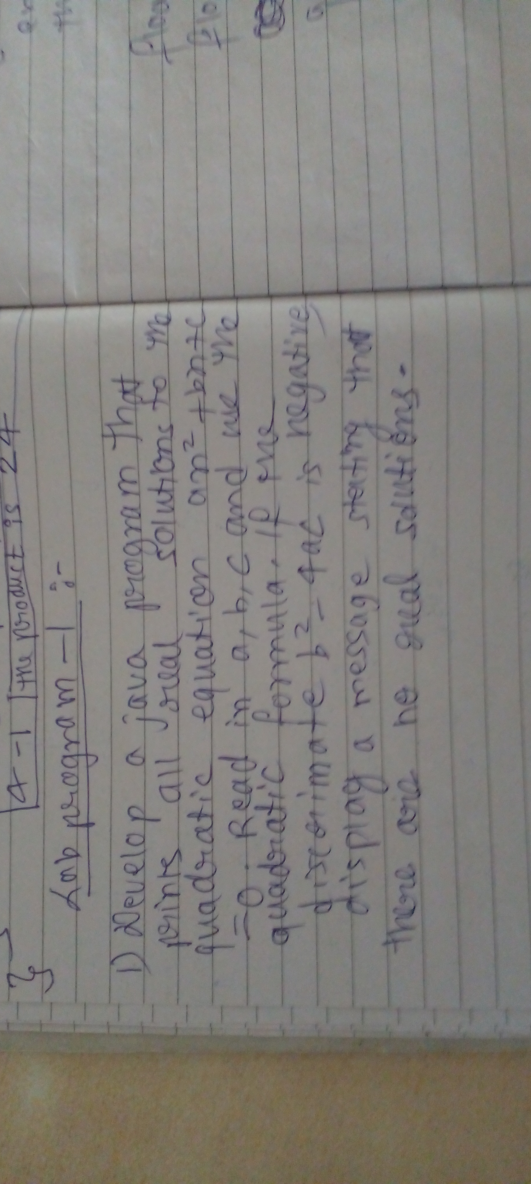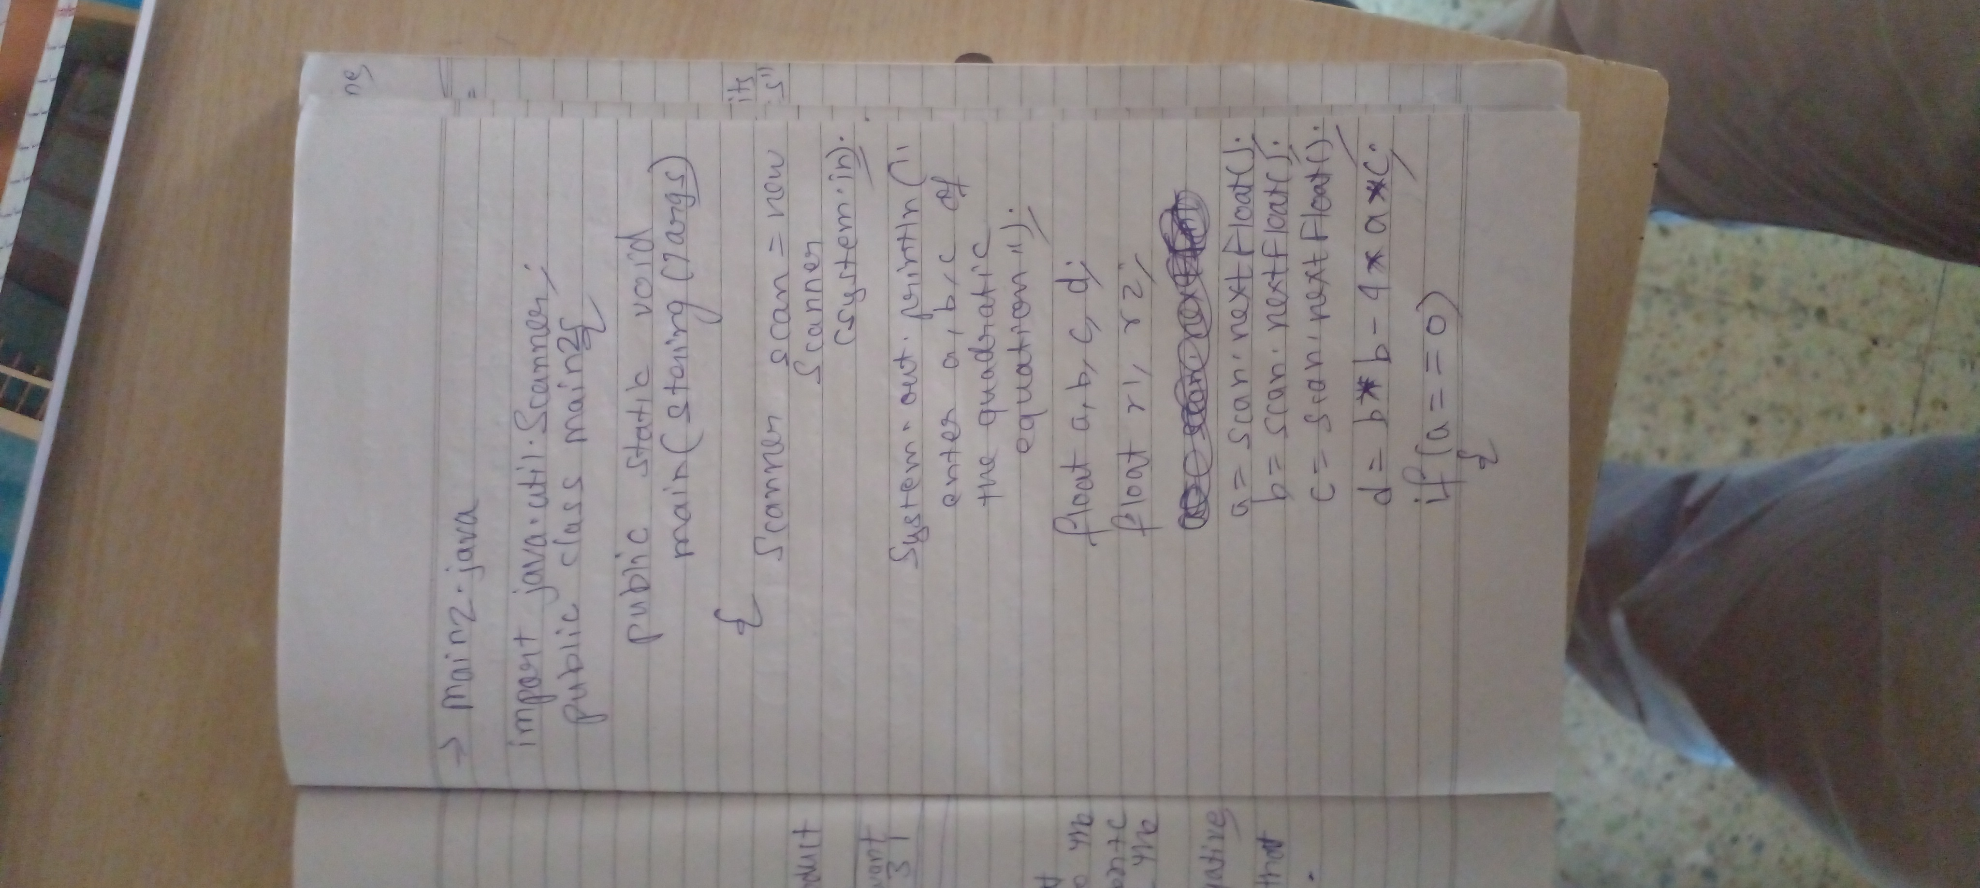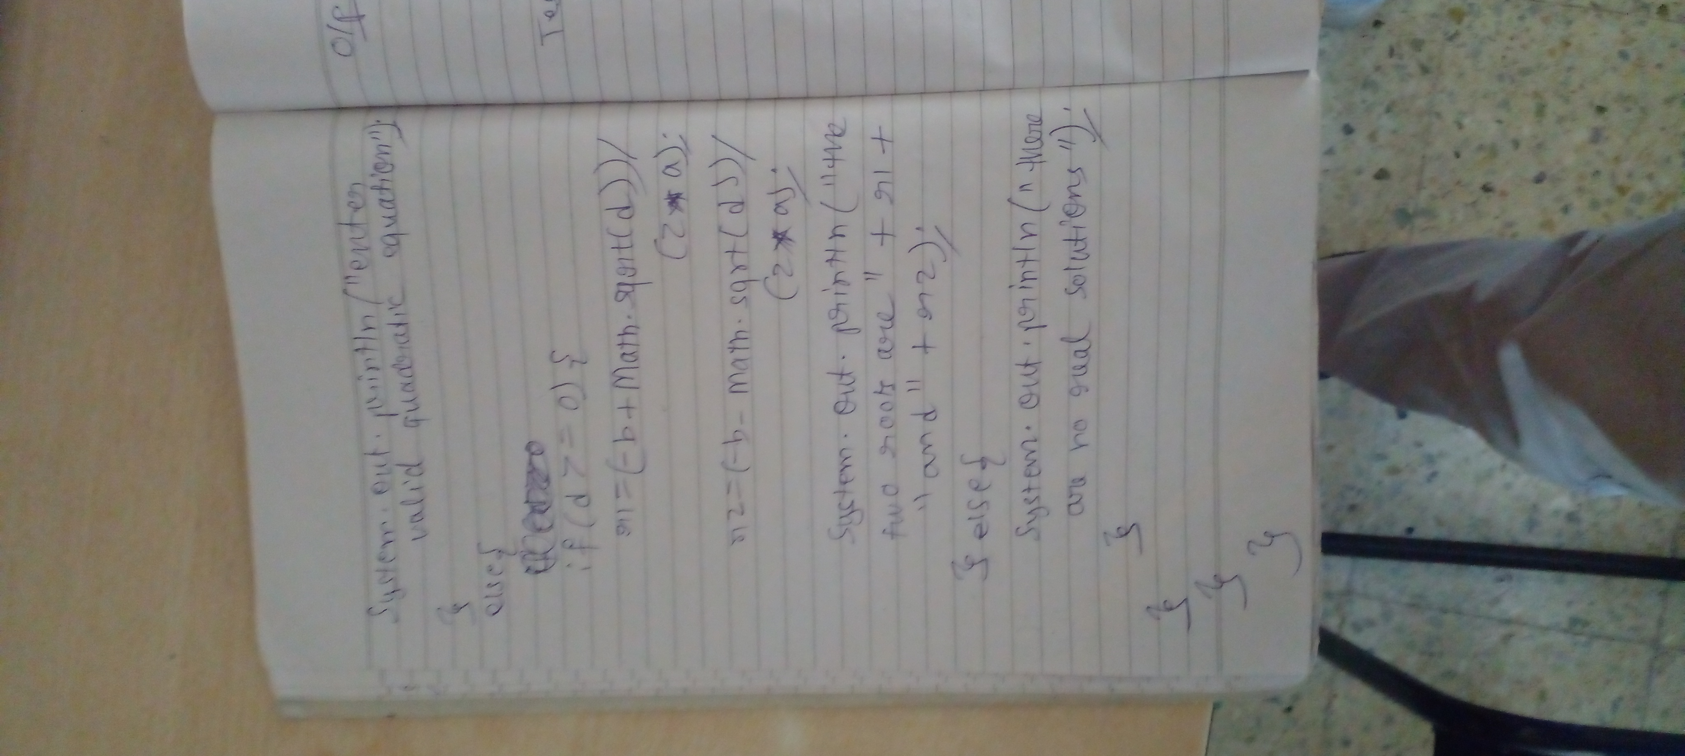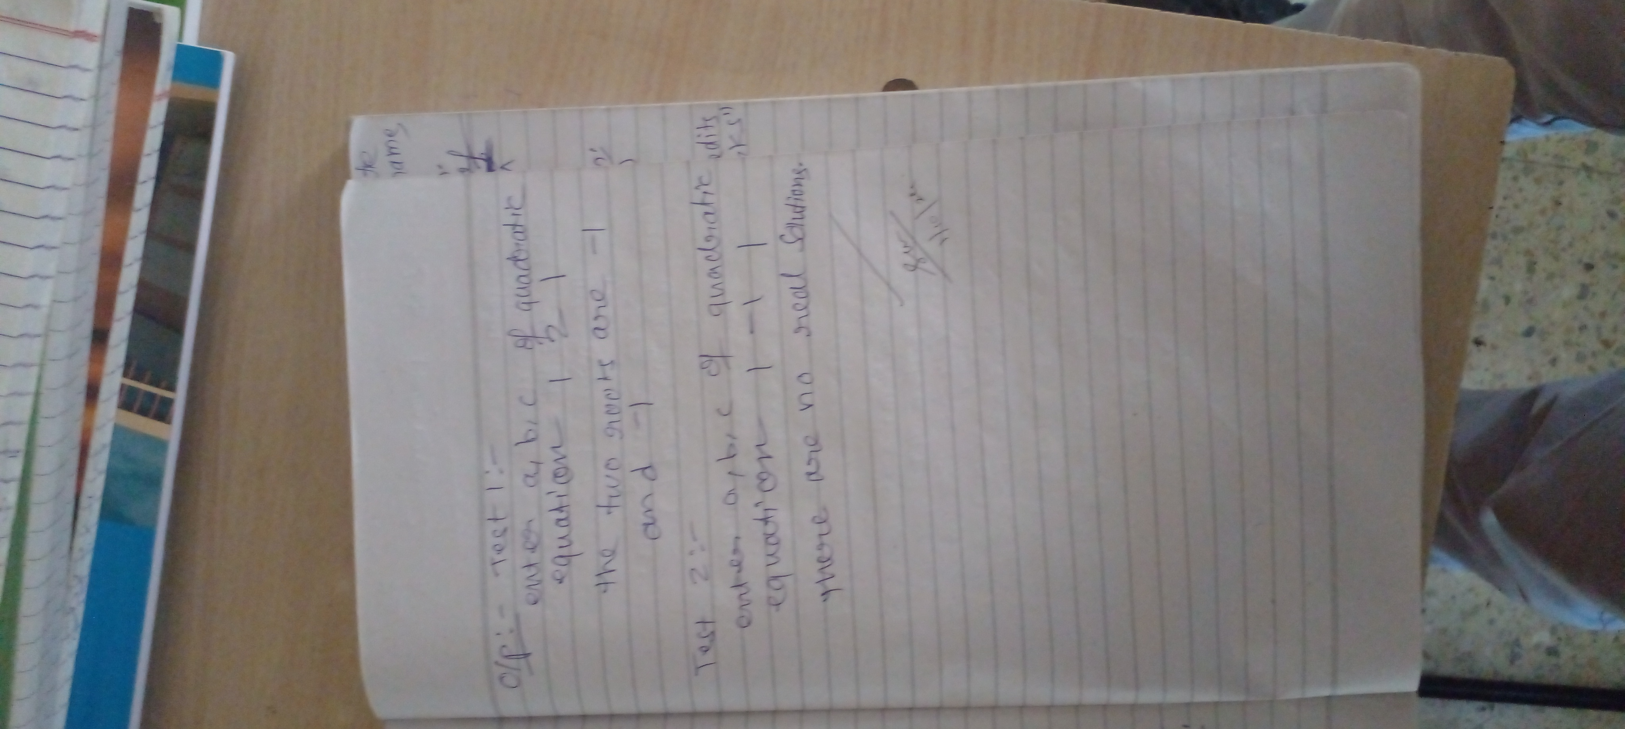

Code:

import java.util.Scanner;

class Main{

public static void main(String[] args){

Scanner scan =new Scanner(System.in);

float a,b,c,d,r1,r2;

System.out.println("enter the value for the a,b,c for the quadratic equation");

a=scan.nextFloat();

b=scan.nextFloat();

c=scan.nextFloat();

d=b*b-4*a*c;

if(a==0){

System.out.println("roots cannot be determined");

}

else{

if(d>=0){

r1=(-b+(float)Math.sqrt(d))/(2*a);

r2=(-b-(float)Math.sqrt(d))/(2*a);

System.out.println("the two roots are "+r1+" and "+r2);

}else{

System.out.println("there are no real solutions");

}

}

}

}

**Program 2**

SGPA PROGRRAM

Algorithm:

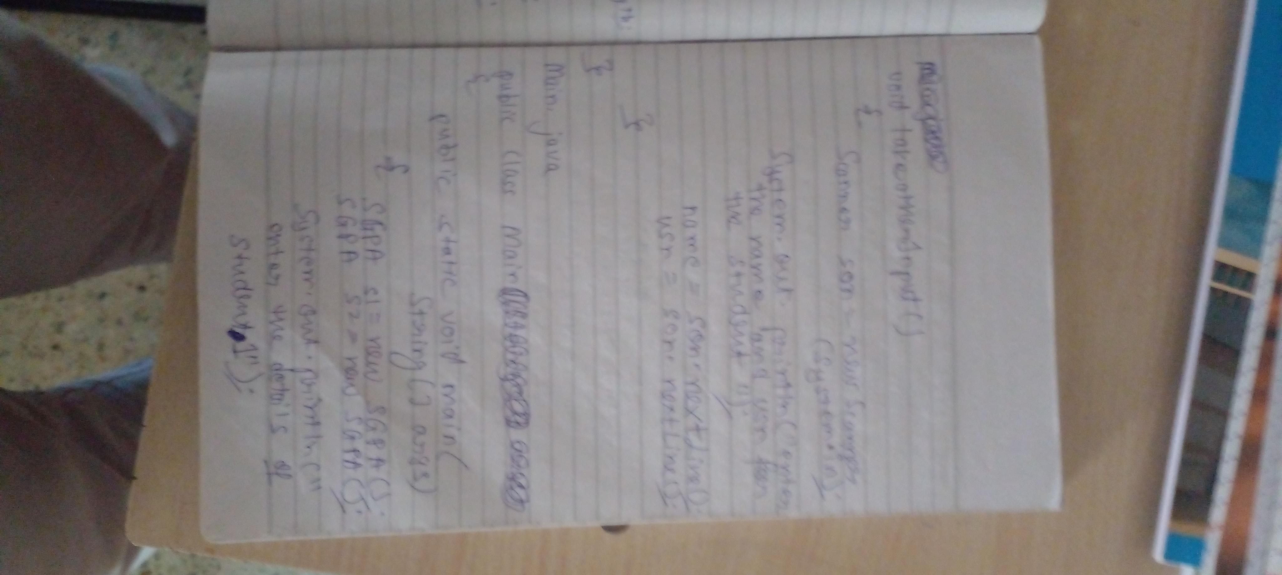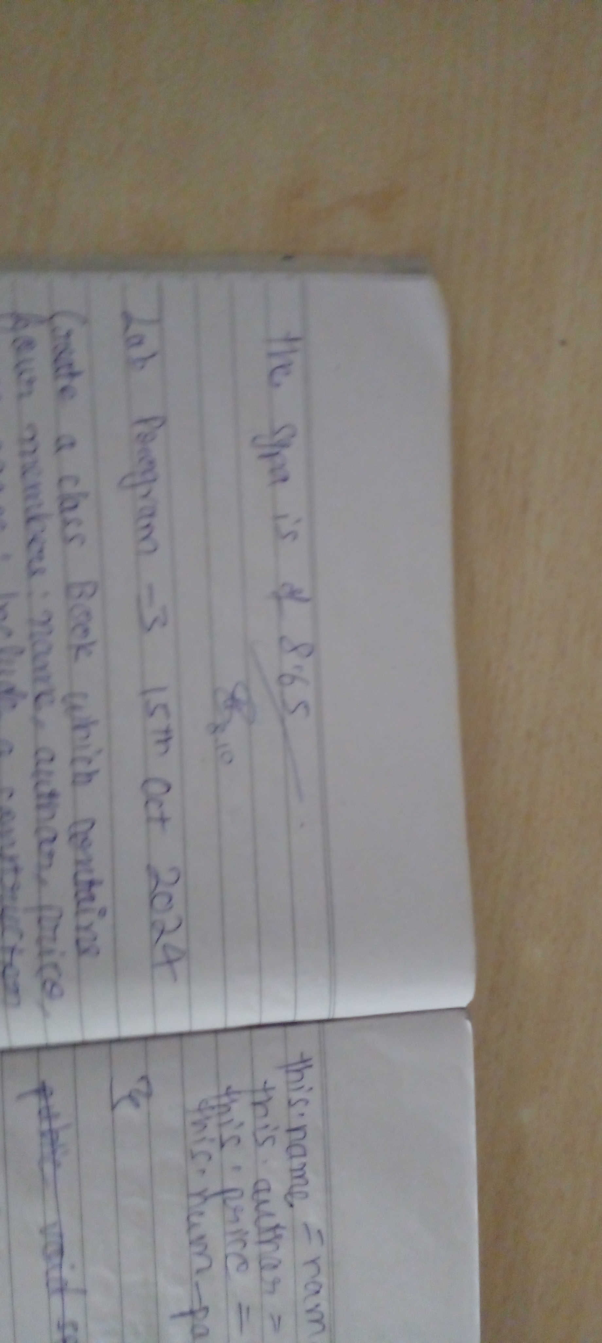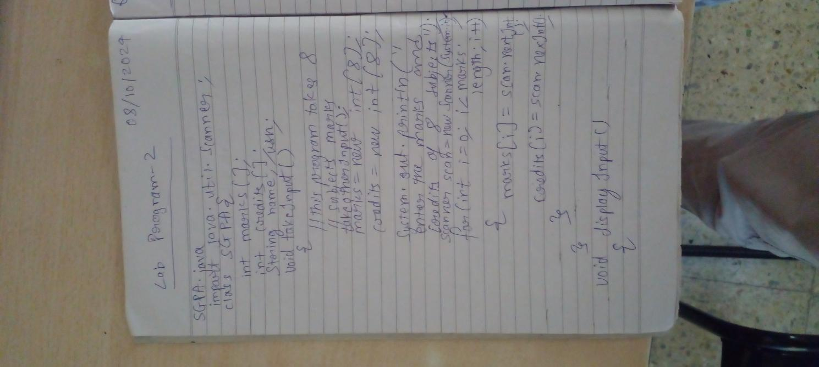

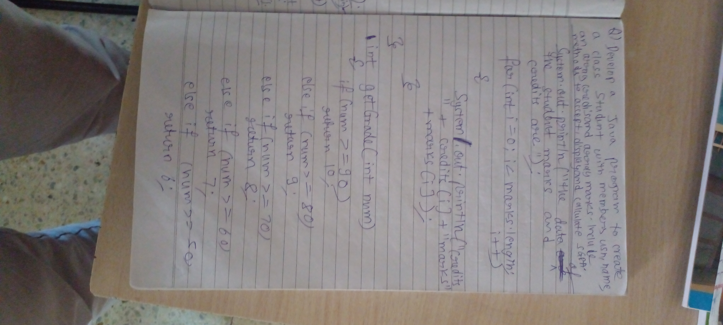

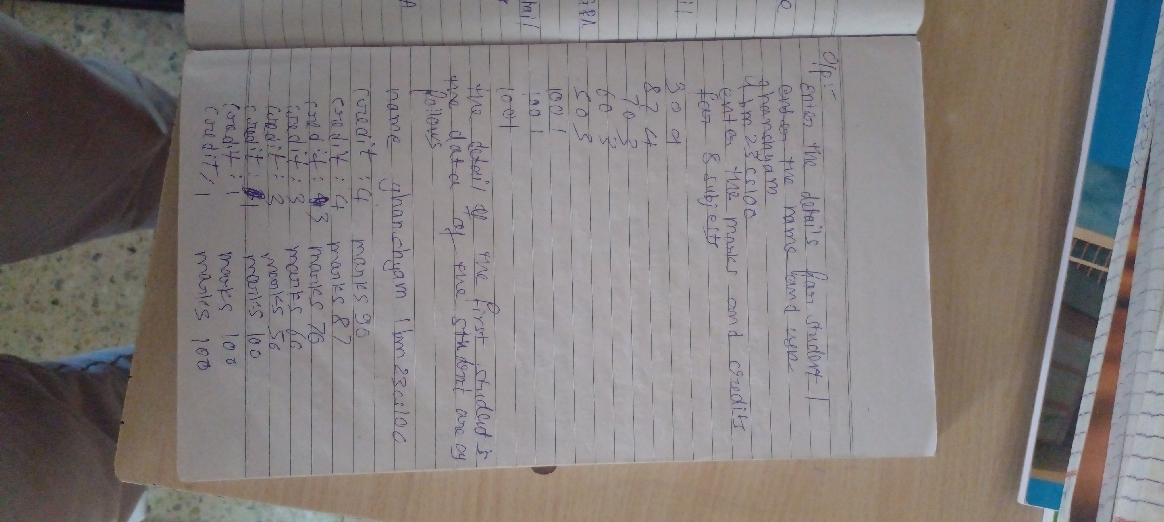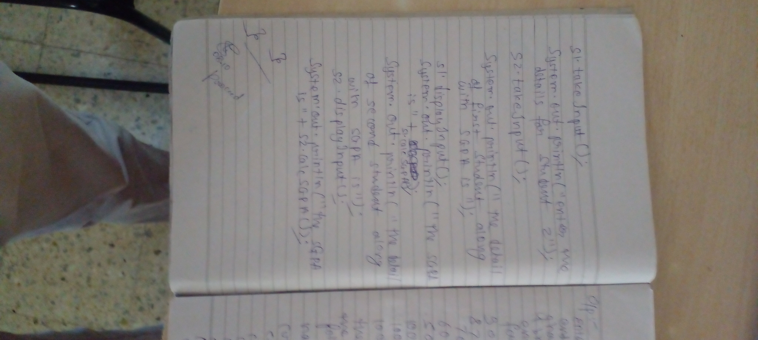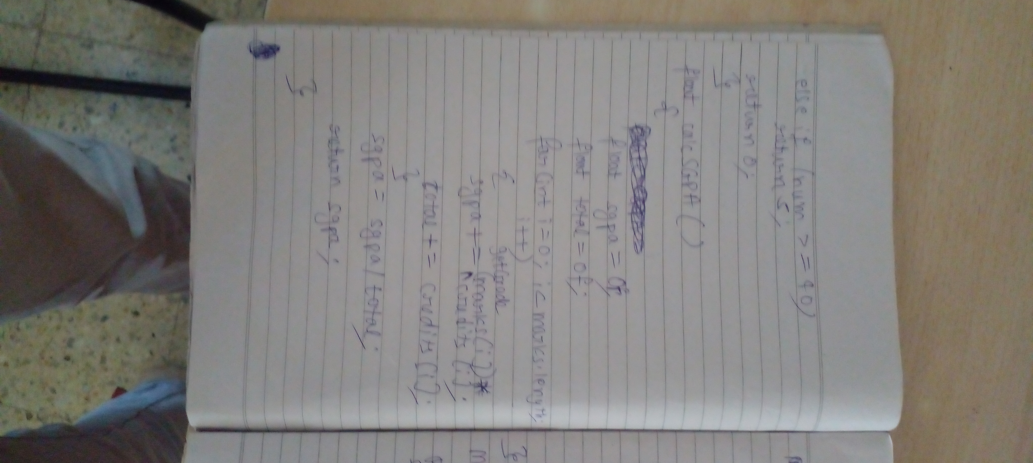

CODE:

import java.util.Scanner;

class Main{

public static void main(String[] args){

SGPA s1=new SGPA();

SGPA s2=new SGPA();

System.out.println("enter the details of student 1");

s1.takeInput();

System.out.println("enter the details of student 2");

s2.takeInput();

System.out.println("the details of the first student along with sgpa is");

s1.displayInput();

System.out.println("the sgpa is "+s1.calcSGPA());

System.out.println("the details of the second student along with sgpa is");

s2.displayInput();

System.out.println("the sgpa is "+s2.calcSGPA());

}

}

class SGPA{

String name,usn;

int[] marks,credits;

void takeInput(){

Scanner scan =new Scanner(System.in);

System.out.println("enter the name and usn of the students");

name=scan.nextLine();

usn=scan.nextLine();

marks=new int[8];

credits=new int[8];

System.out.println("now enter the marks and credits of 8 subjects");

for(int i=0;i<8;i++){

marks[i]=scan.nextInt();

credits[i]=scan.nextInt();

}

}

void displayInput(){

System.out.println("the data of the students marks and credits are");

System.out.println("name :"+name+" usn: "+usn);

for(int i=0;i<8;i++){

System.out.println("credits :"+credits[i]+" marks: "+marks[i]);

}

}

int getGrade(int num){

if(num>=90){

return 10;

}

else if(num>=80){

return 9;

}

else if(num>=70){

return 8;

}

else if(num>=60){

return 7;

}

else if(num>=50){

return 6;

}

else if(num>=40){

return 5;

}

return 0;

}

float calcSGPA(){

float sgpa=0f;

float total=0f;

for(int i=0;i<8;i++){

sgpa+=getGrade(marks[i])*credits[i];

total+=credits[i];

}

sgpa/=total;

return sgpa;

}

}

OUTPUT:

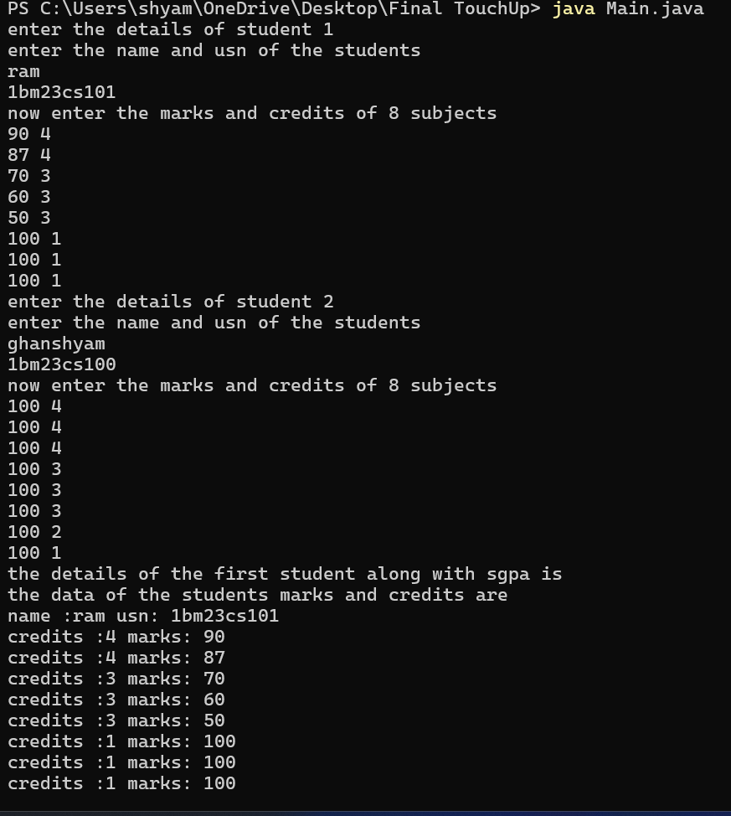

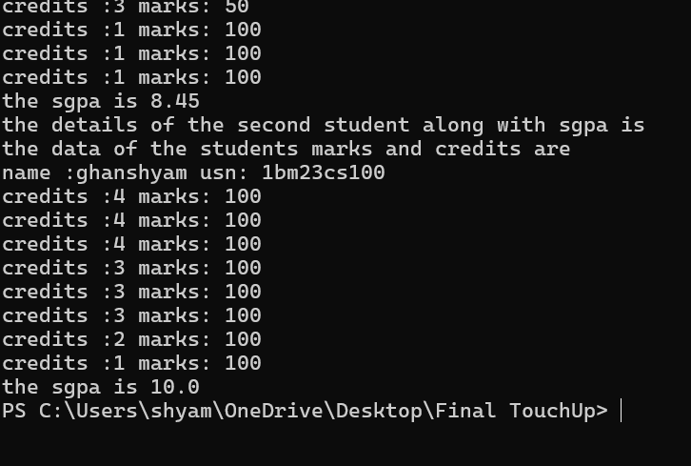

PROGRAM 3:

BOOKS

ALGORITHMS

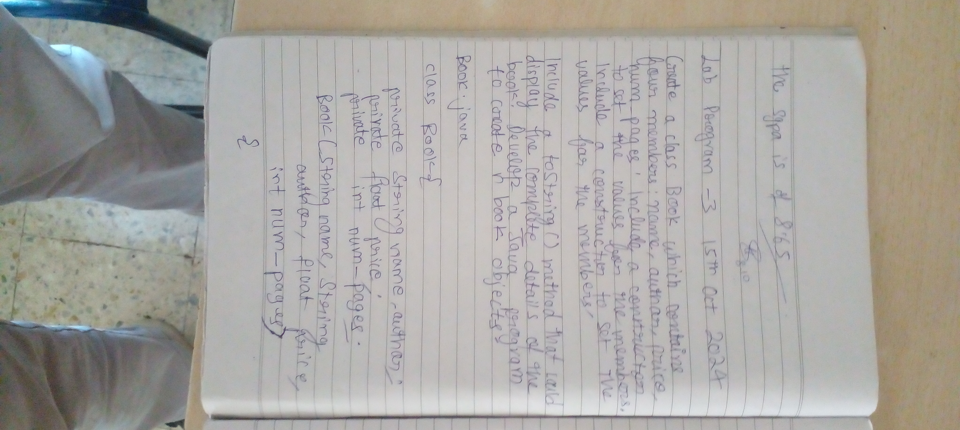



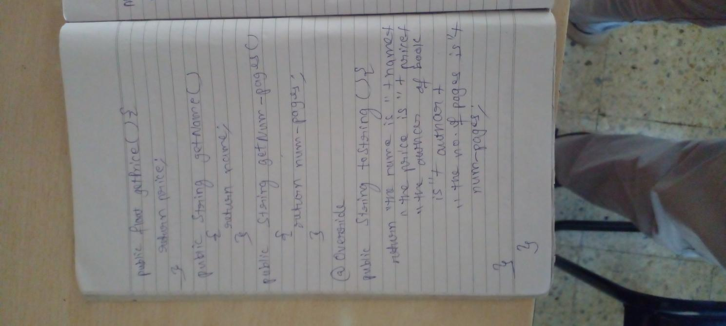

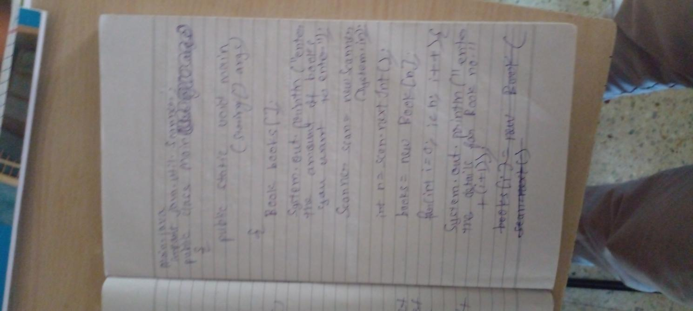

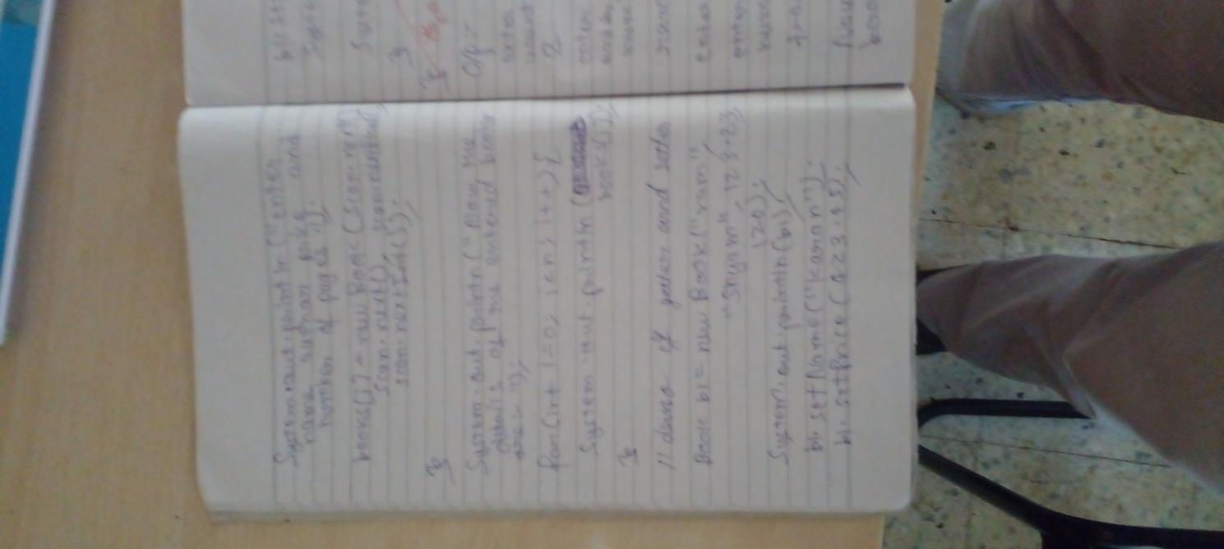

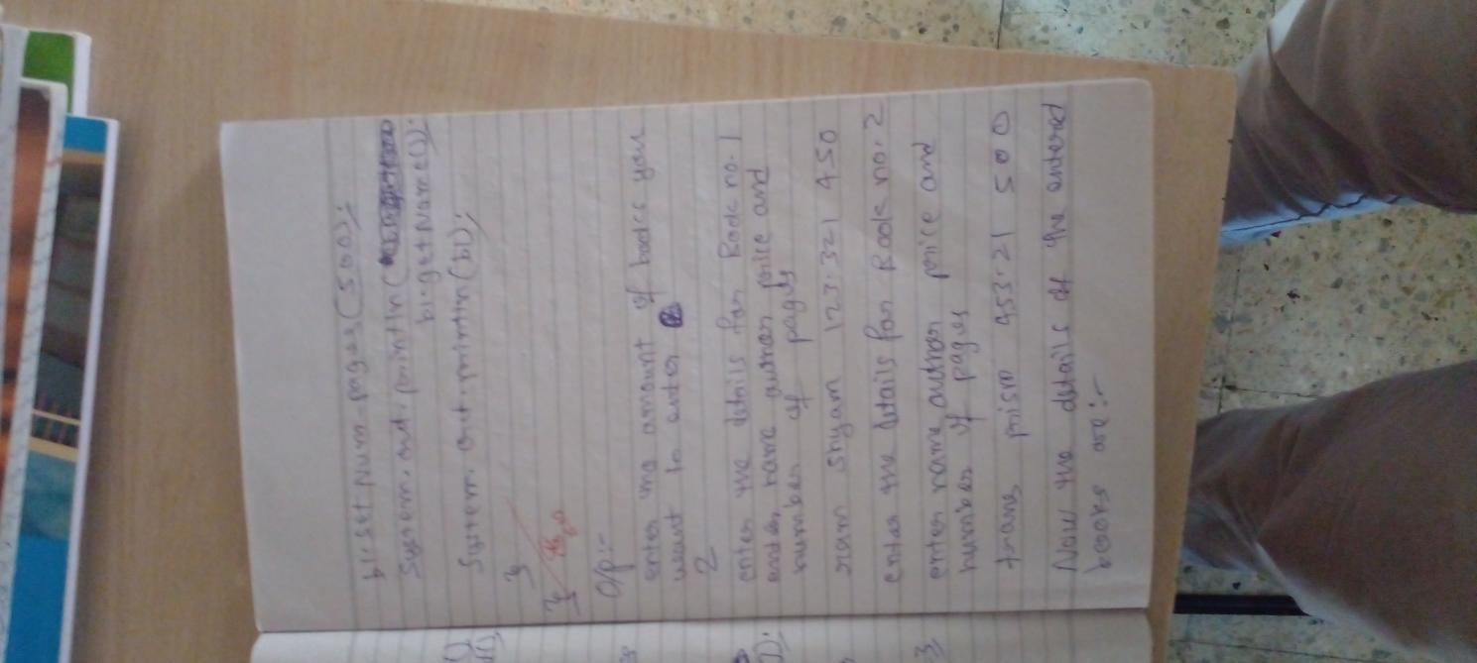

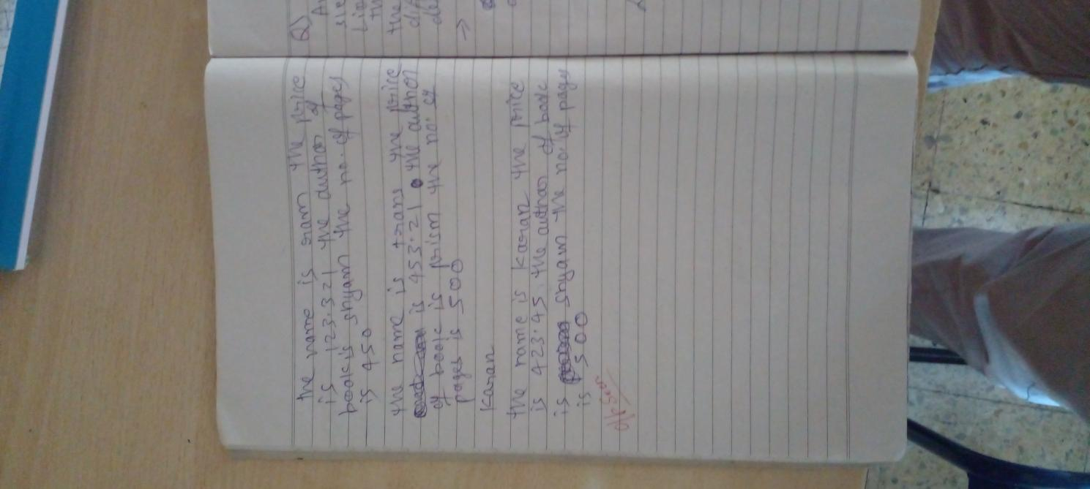

CODE

import java.util.Scanner;

class Main{

public static void main(String[] args){

Scanner scan=new Scanner(System.in);

System.out.println("enter the amount of books you want to enter");

Book[] books;

int n=scan.nextInt();

books =new Book[n];

for(int i=0;i<n;i++){

System.out.println("enter the details for Book no. "+(i+1));

System.out.println("enter name author price and number of pages");

books[i]=new Book(scan.next(),scan.next(),scan.nextDouble(),scan.nextInt());

}

System.out.println("now the details of the entered books are:-");

for(int i=0;i<n;i++){

System.out.println(books[i]);

}

//demo of getters and setters

Book b1=new Book("ram","Shyam",123.23,120);

System.out.println(b1);

b1.setName("karan");

b1.setPrice(423.45);

b1.setNum_pages(500);

System.out.println(b1.getName());

System.out.println(b1);

}

}

class Book{

String name;

String author;

double price;

int num_pages;

Book(String name,String author,double price,int num_pages){

this.name=name;

this.author=author;

this.price=price;

this.num_pages=num_pages;

}

void setName(String name){

this.name=name;

}

void setAuthor(String author){

this.author=author;

}

void setPrice(double price){

this.price=price;

}

void setNum_pages(int num_pages){

this.num_pages=num_pages;

}

String getName(){

return name;

}

String getAuthor(){

return author;

}

double getPrice(){

return price;

}

int getNum_pages(){

return num_pages;

}

public String toString(){

return "the name is "+name+" the price is "+price+" the author of book is "+author+" the no of pages is "+num_pages;

}

}

OUTPUT

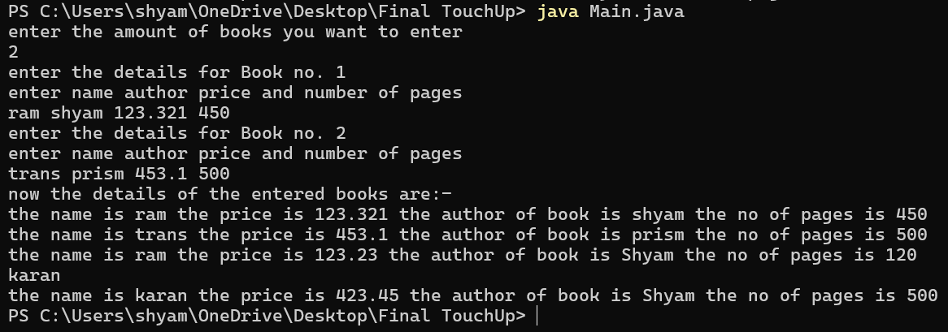

PROGRAM 4

ANIMAL ABSTRACT CLASS

ALGORITHM:

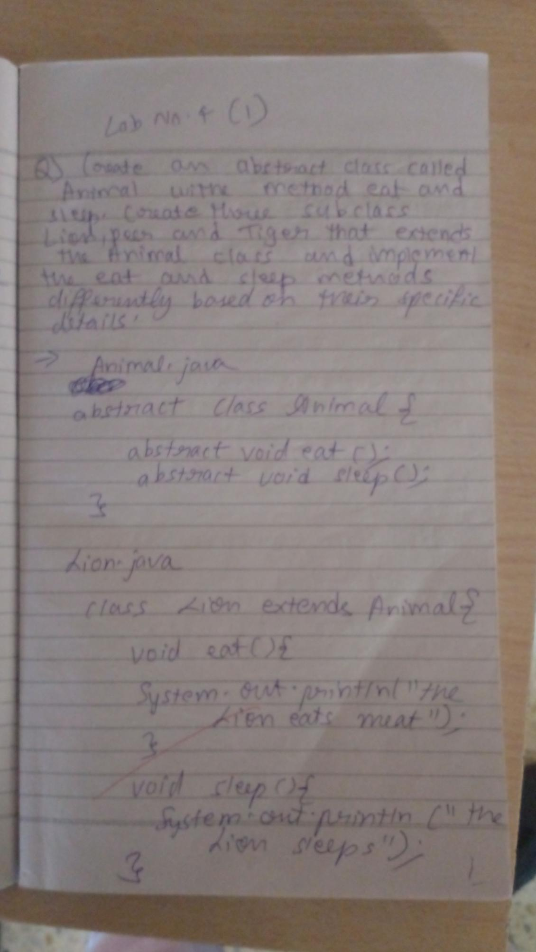

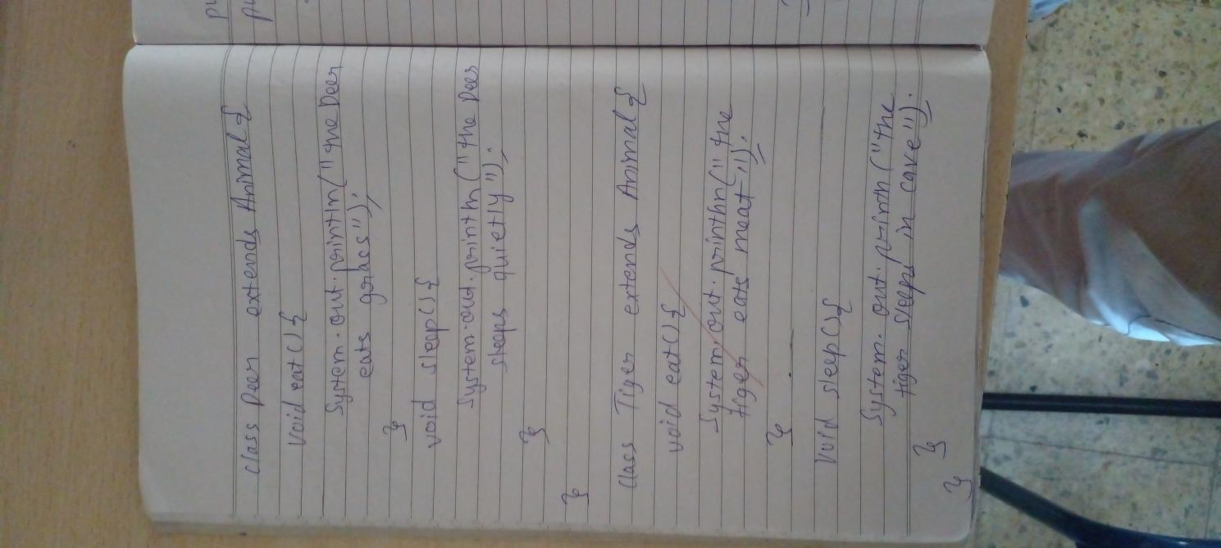

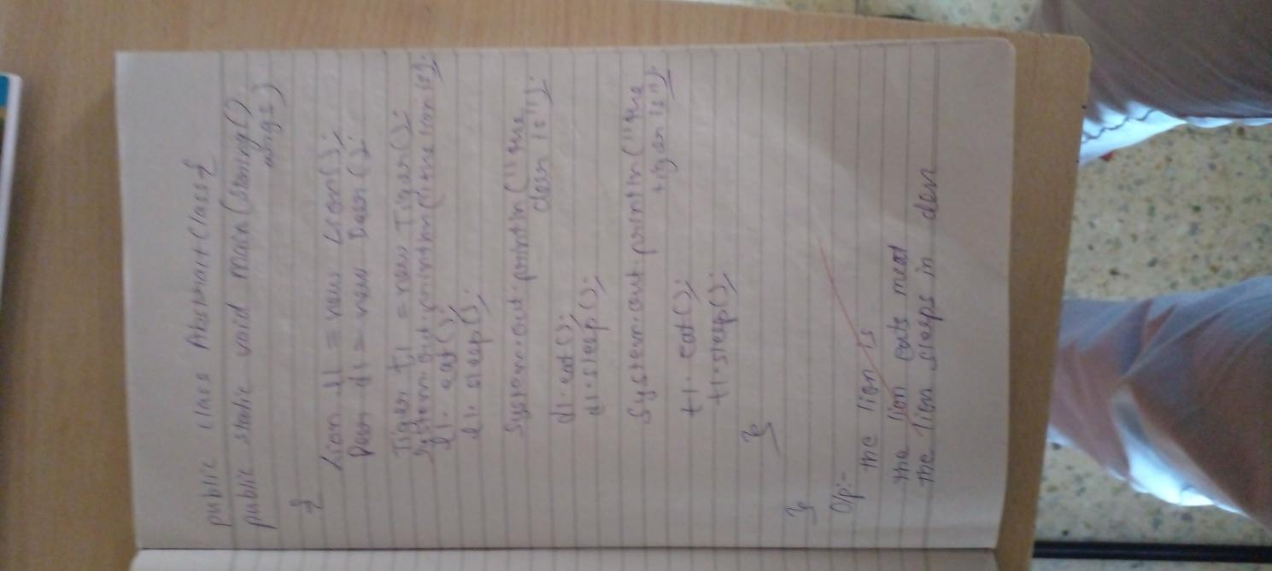

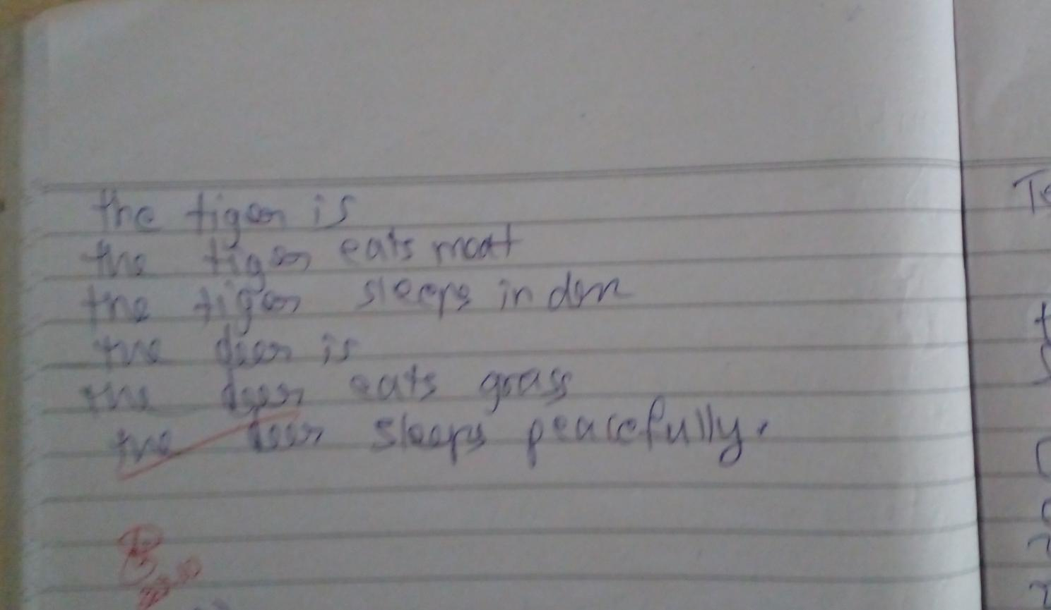

CODE:

class Main{

public static void main(String[] args){

Lion l1=new Lion();

Deer d1=new Deer();

Tiger t1=new Tiger();

System.out.println("the lion is ");

l1.eat();

l1.sleep();

System.out.println("the deer is ");

d1.eat();

l1.sleep();

System.out.println("the tiger is ");

t1.eat();

t1.sleep();

}

}

abstract class Animal{

abstract void eat();

abstract void sleep();

}

class Lion extends Animal{

void eat(){

System.out.println("the lion eats meat");

}

void sleep(){

System.out.println("the Lion sleeps");

}

}

class Deer extends Animal{

void eat(){

System.out.println("the deer eats grass");

}

void sleep(){

System.out.println("the deer sleeps quietly");

}

}

class Tiger extends Animal{

void eat(){

System.out.println("the tiger eats meat");

}

void sleep(){

System.out.println("the tiger sleeps in cave");

}

}

OUTPUT:

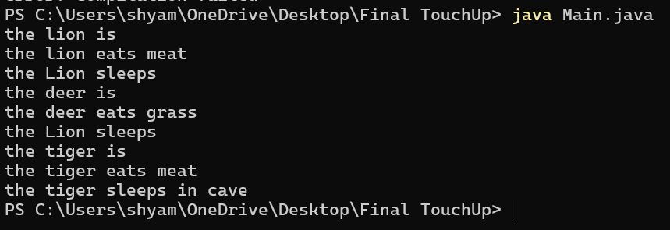

LAB PROGRAM 4(B):

SHAPES ABSTRACT CLASS

ALGORITHM:

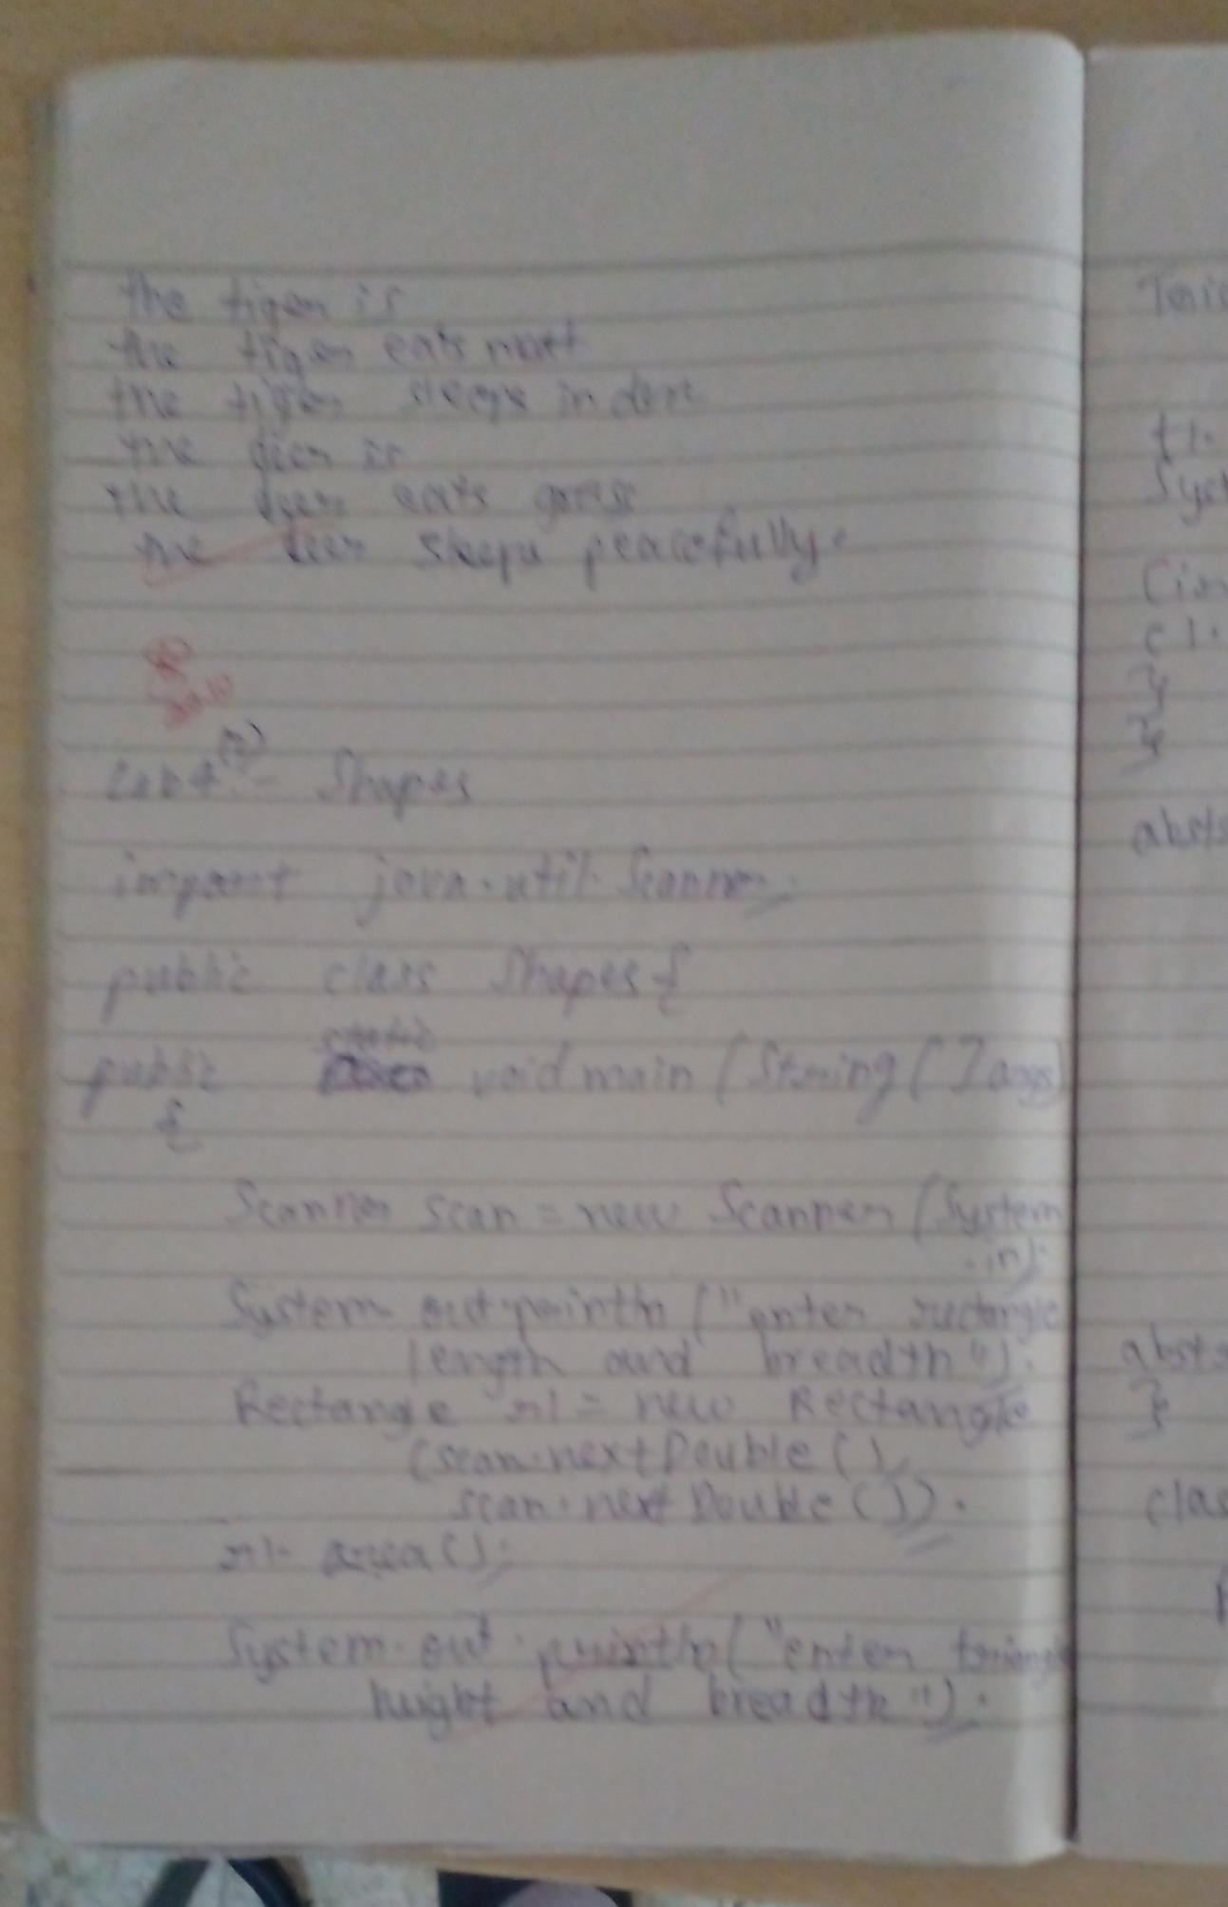

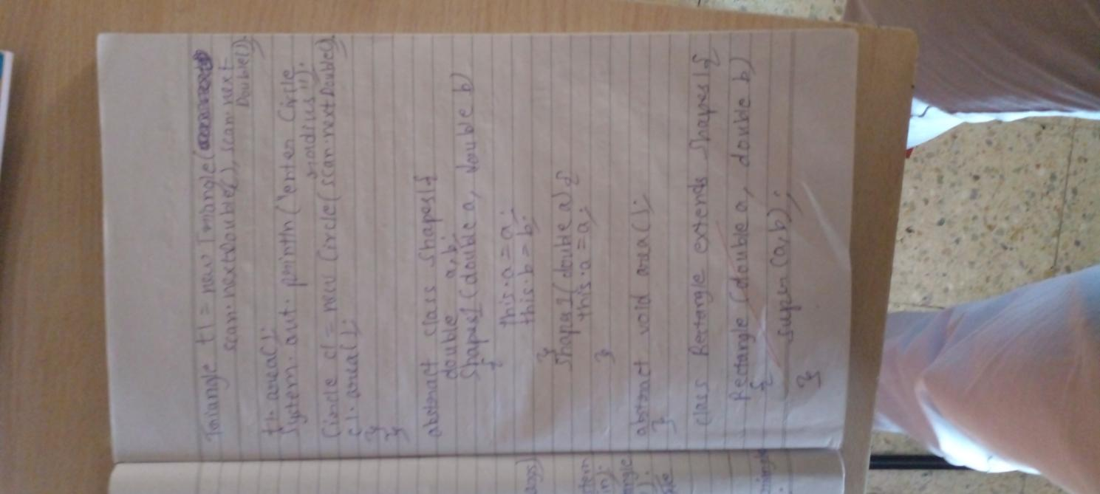

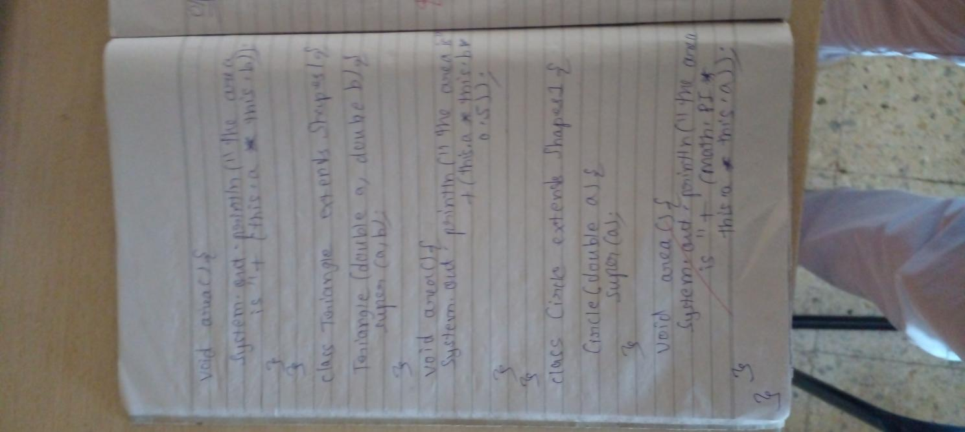

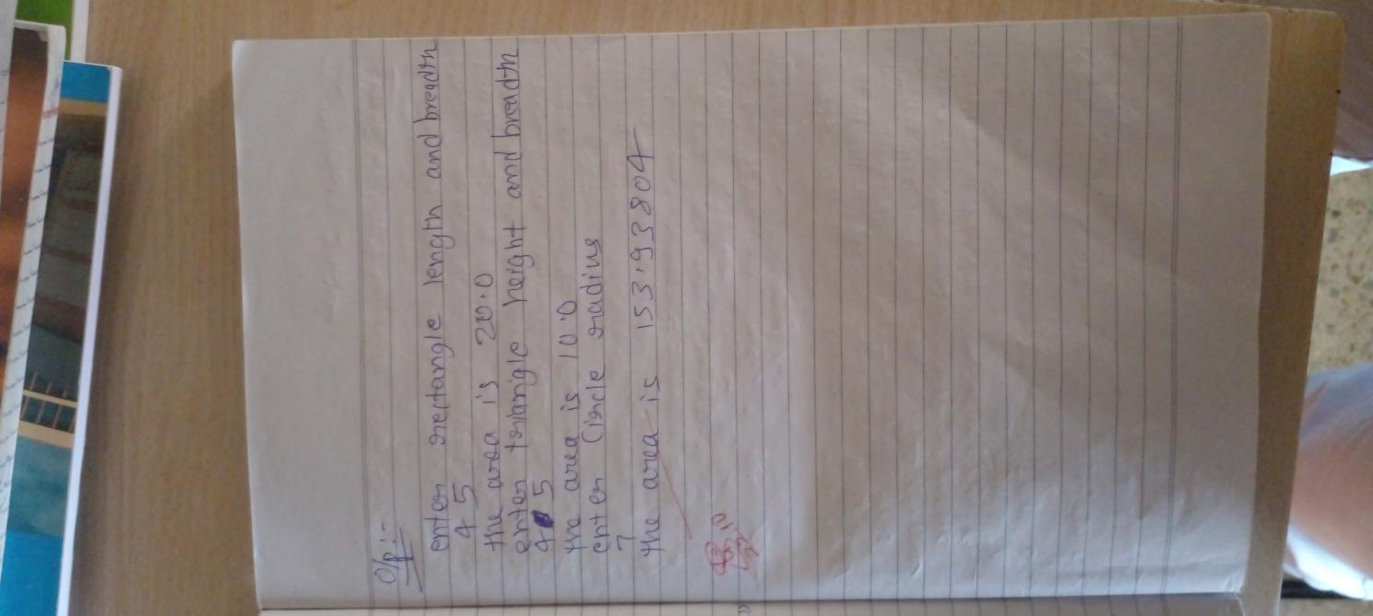

CODE:

import java.util.Scanner;

class Main{

public static void main(String[] args){

Scanner scan =new Scanner(System.in);

System.out.println("enter the rectangle length and breadth");

Rectangle r1=new Rectangle(scan.nextDouble(),scan.nextDouble());

r1.area();

System.out.println("enter the triangle breadth and height");

Triangle t1=new Triangle(scan.nextDouble(),scan.nextDouble());

t1.area();

System.out.println("enter the circle radius");

Circle c1=new Circle(scan.nextDouble());

c1.area();

}

}

abstract class Shapes{

double a,b;

Shapes(double a,double b){

this.a=a;

this.b=b;

}

Shapes(double a){

this.a=a;

}

abstract void area();

}

class Rectangle extends Shapes{

Rectangle(double a,double b){

super(a,b);

}

void area(){

System.out.println("the area is "+(this.a*this.b));

}

}

class Triangle extends Shapes{

Triangle(double a,double b){

super(a,b);

}

void area(){

System.out.println("the area is "+(this.a*this.b*0.5));

}

}

class Circle extends Shapes{

Circle(double a)

{

super(a);

}

void area(){

System.out.println("the area is "+(Math.PI*this.a*this.a));

}

}

OUTPUT:

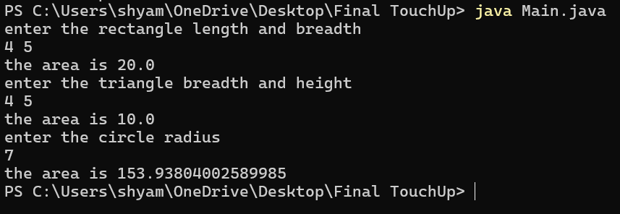

PROGRAM 5:

BANK

ALGORITHMS:

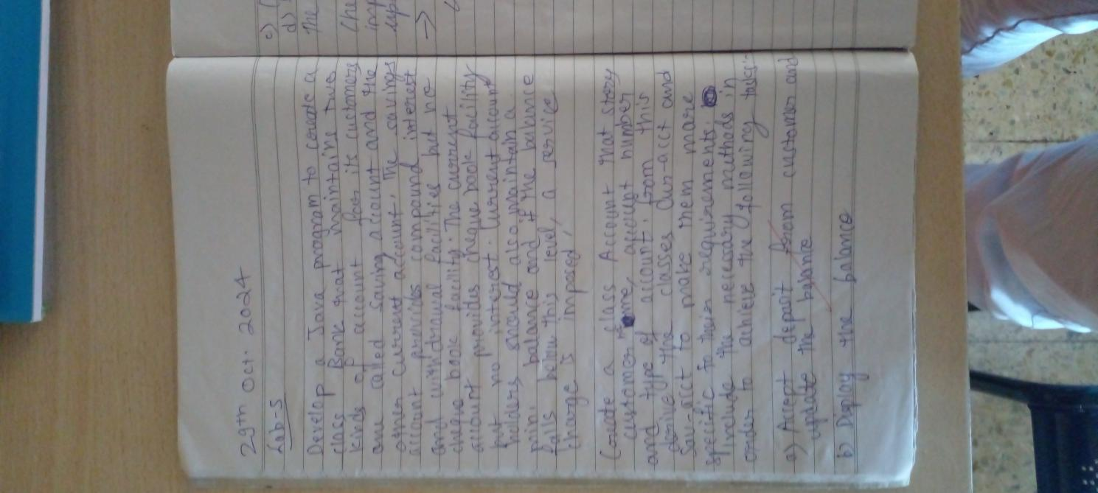

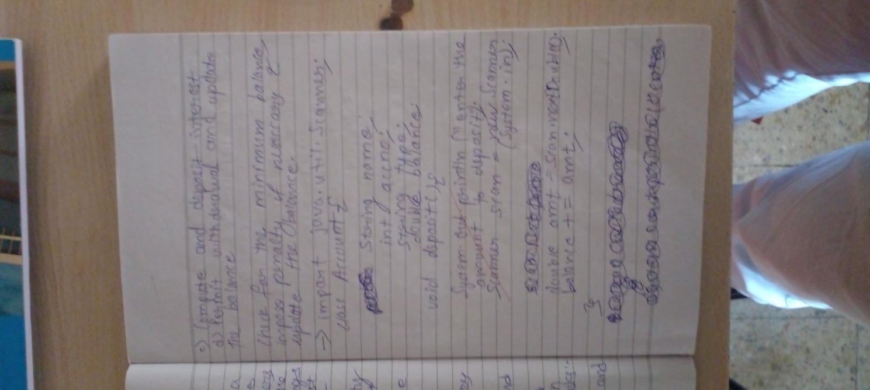

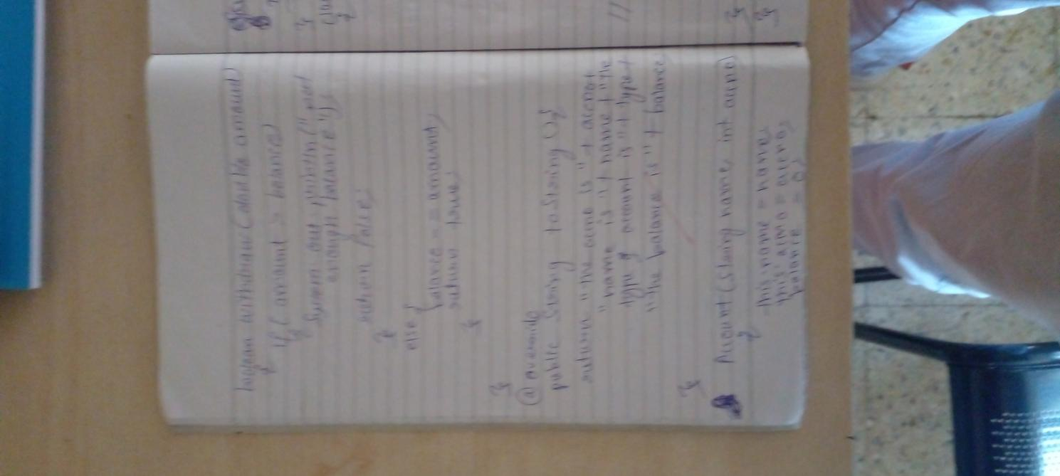

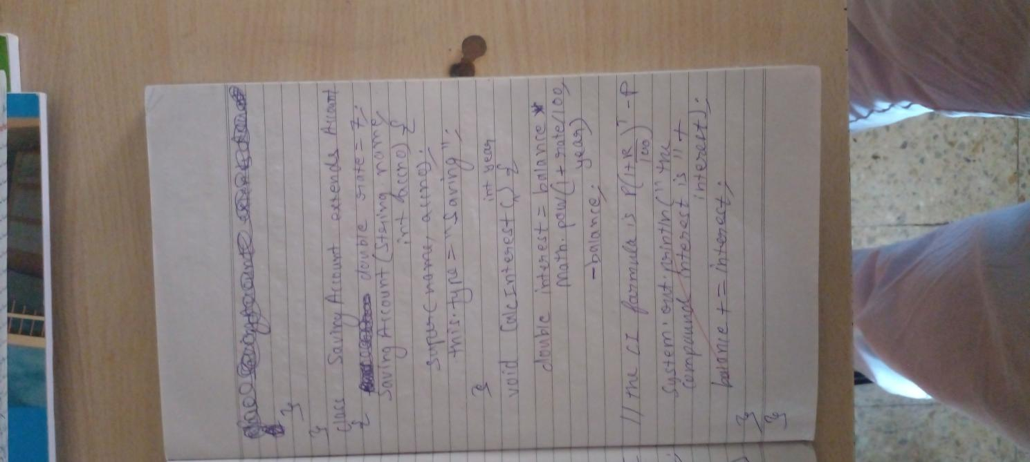

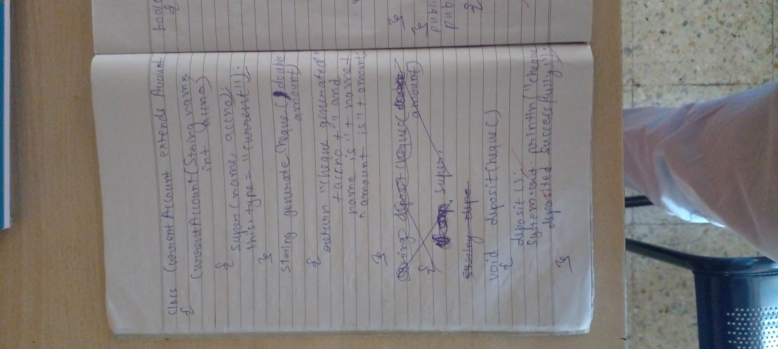

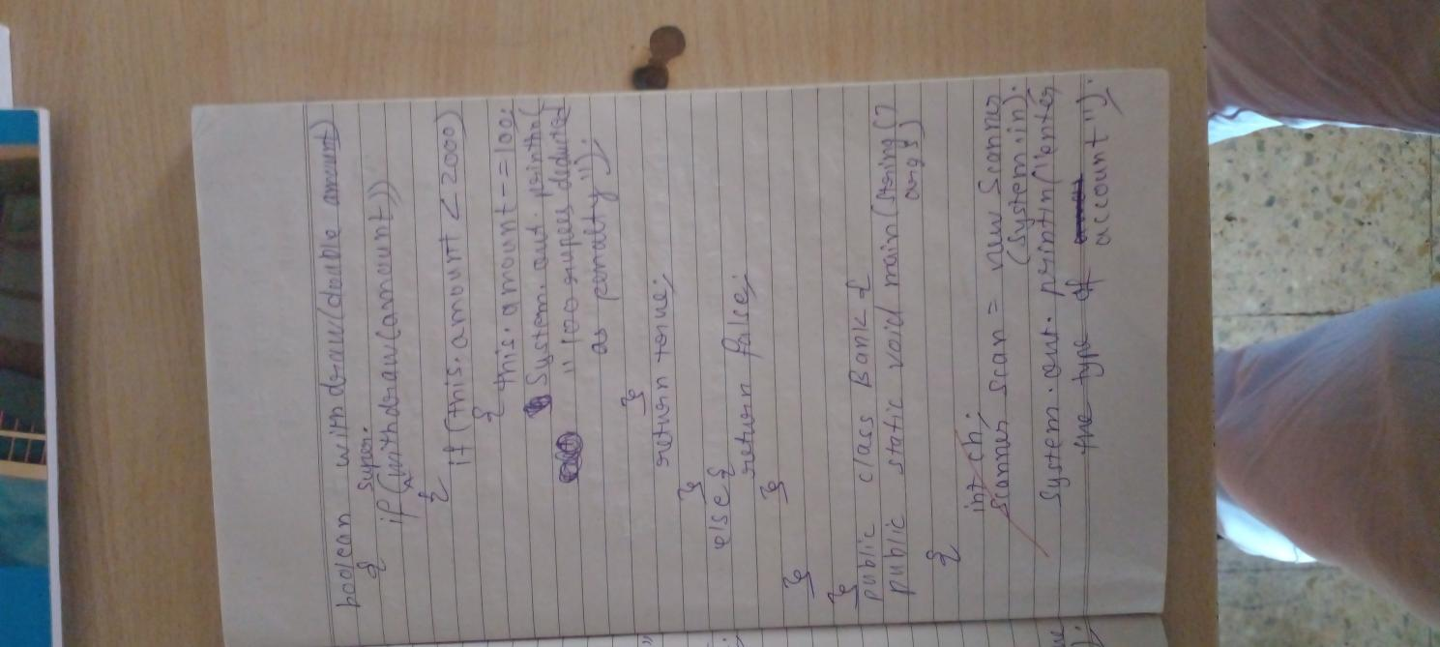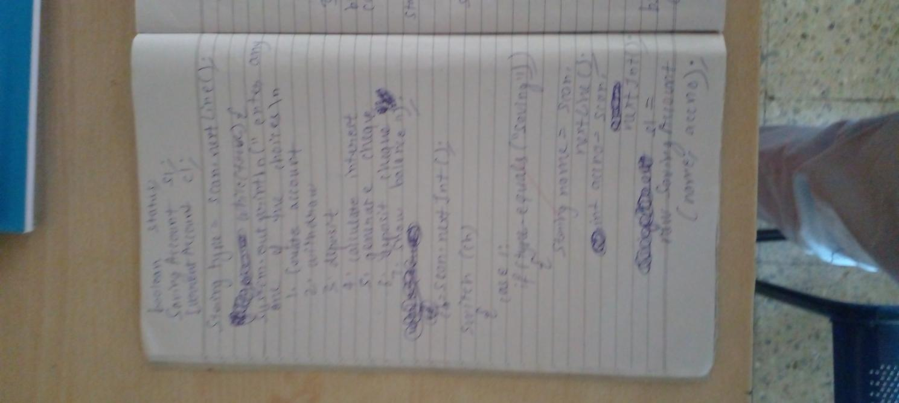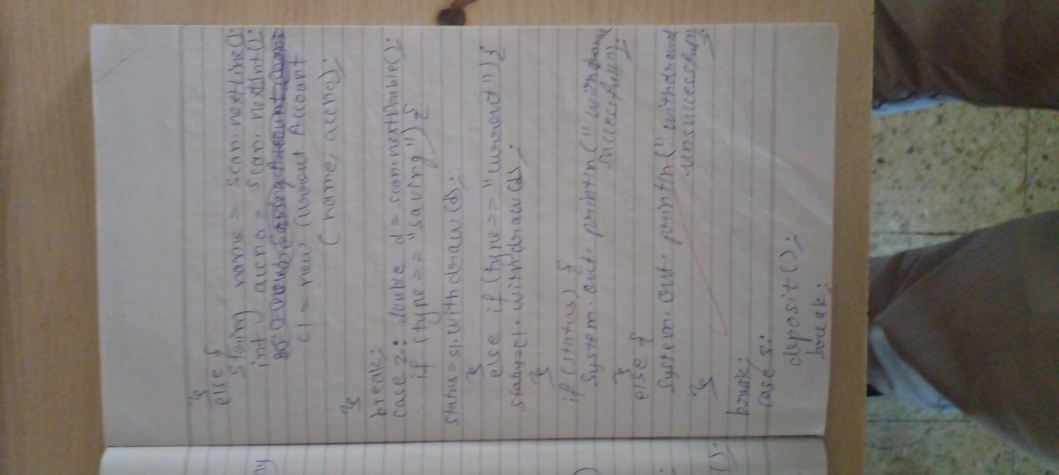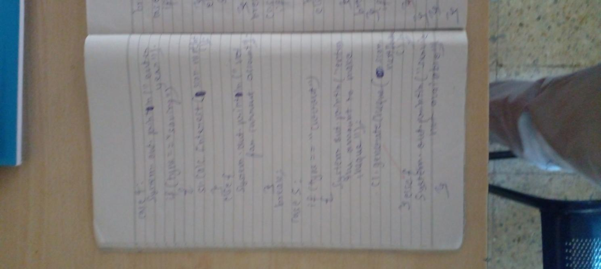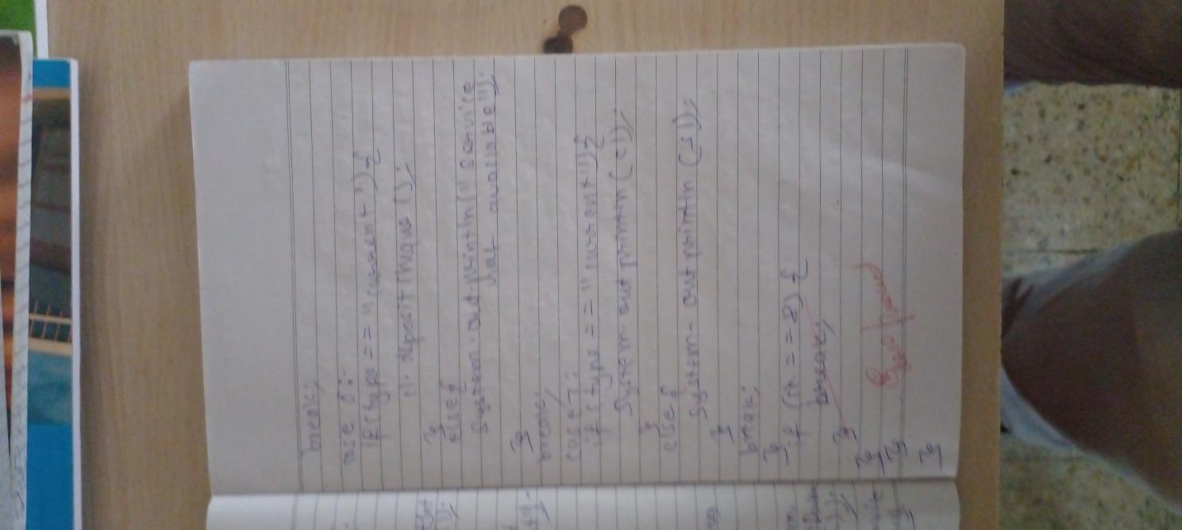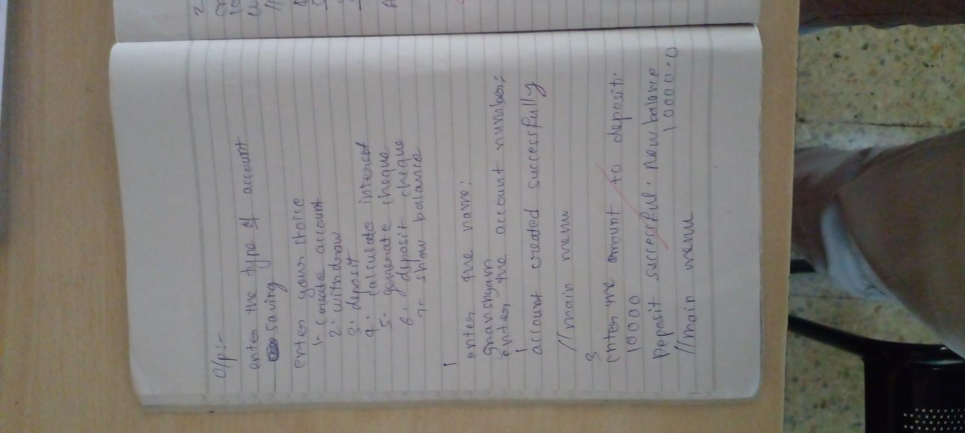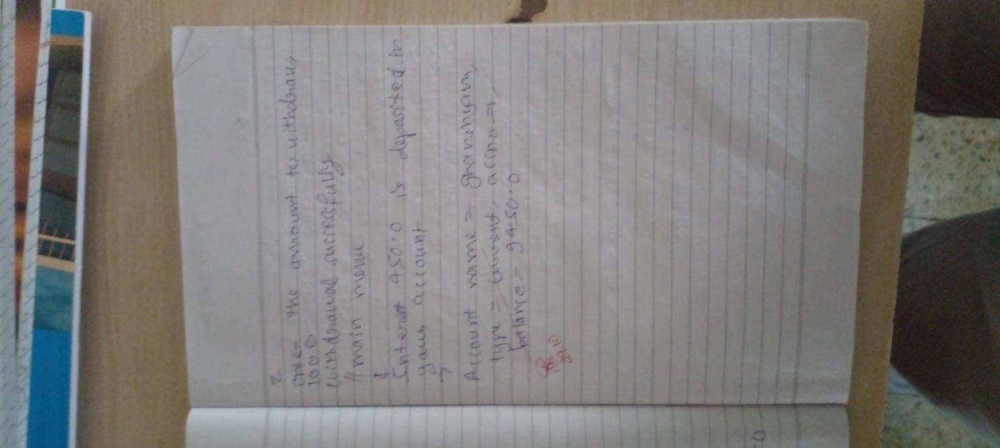

CODE:

import java.util.Scanner;

class Main{

public static void main(String[] args){

int ch;

Scanner scan=new Scanner(System.in);

System.out.println("enter the type of account");

boolean status;

Account s=null;

String type=scan.nextLine();

while(true){

System.out.println("enter any one of the choices\n1.CreateAccont\n2.withdraw\n3.deposit\n4.calculate interest\n5.generate cheque\n6.deposit cheque\n7.show balance");

ch=scan.nextInt();

switch(ch){

case 1:

if(type.equalsIgnoreCase("Saving")){

System.out.println("enter the name and account number");

String name =scan.next();

int accno =scan.nextInt();

s=new SavingAccount(name,accno);

}else{

System.out.println("enter the name and account number");

String name =scan.next();

int accno =scan.nextInt();

s=new CurrentAccount(name,accno);

}

System.out.println("account create successfully");

break;

case 2:

System.out.println("enter the amount to withdraw");

double d=scan.nextDouble();

if(s.withdraw(d)){

System.out.println("withdraw successfully");

}else{

System.out.println("withdraw unsuccessfully");

}

break;

case 3:

s.deposit();

break;

case 4:

System.out.println("enter year");

s.CalcInterest(scan.nextInt());

break;

case 5:

System.out.println("enter the amount to make cheque");

System.out.println(s.generateCheque(scan.nextDouble()));

break;

case 6:

s.depositCheque();

break;

case 7:

System.out.println(s);

break;

}

if(ch==8)break;

}

}

}

abstract class Account{

String name;

int accno;

double balance;

String type;

Account(String name,int accno){

this.name=name;

this.accno=accno;

}

void deposit(){

Scanner scan =new Scanner(System.in);

System.out.println("enter the amount to deposit");

balance+=scan.nextDouble();

System.out.println("deposit successful.New balance "+balance);

}

void CalcInterest(int year){

System.out.println("service not available");

}

boolean withdraw(double amount){

if(amount>balance){

System.out.println("not enough amount to withdraw");

return false;

}else{

System.out.println("amount "+amount+" withdrawn succcessfully");

balance-=amount;

return true;

}

}

abstract String generateCheque(double amount);

abstract void depositCheque();

public String toString(){

return "the accno is "+accno+" name is "+name+" the account type is "+type+" the balance is "+balance;

}

}

class SavingAccount extends Account{

double rate=7;

SavingAccount(String name,int age){

super(name,age);

this.type="Saving";

}

void CalcInterest(int year){

double interest=balance *year*rate/100;

System.out.println("the compound interest is "+interest);

balance += interest;

}

String generateCheque(double amount){

return "service not available in saving account";

}

void depositCheque(){

System.out.println("service not available in saving account");

}

}

class CurrentAccount extends Account{

CurrentAccount(String name,int accno){

super(name,accno);

this.type="Current";

}

String generateCheque(double amount){

return "cheque generated "+accno +" and name is "+name+" amount is "+amount;

}

void depositCheque(){

deposit();

System.out.println("the cheque deposited successfully");

}

boolean withdraw( double amount){

if(super.withdraw(amount)){

if(this.balance<2000){

this.balance-=100;

System.out.println("100 rupees deducted as penalty");

}

return true;

}else{

return false;

}

}

}

OUTPUT:

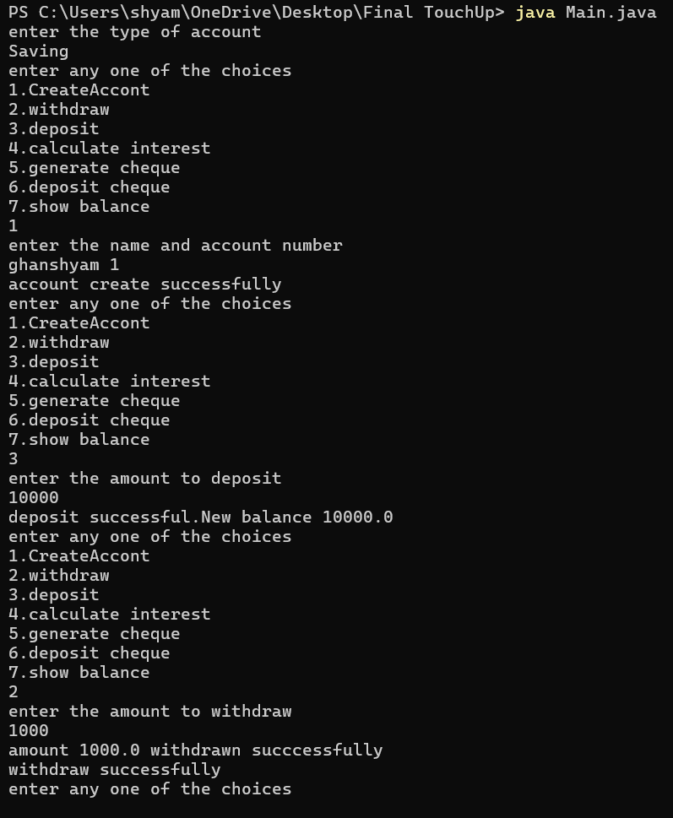

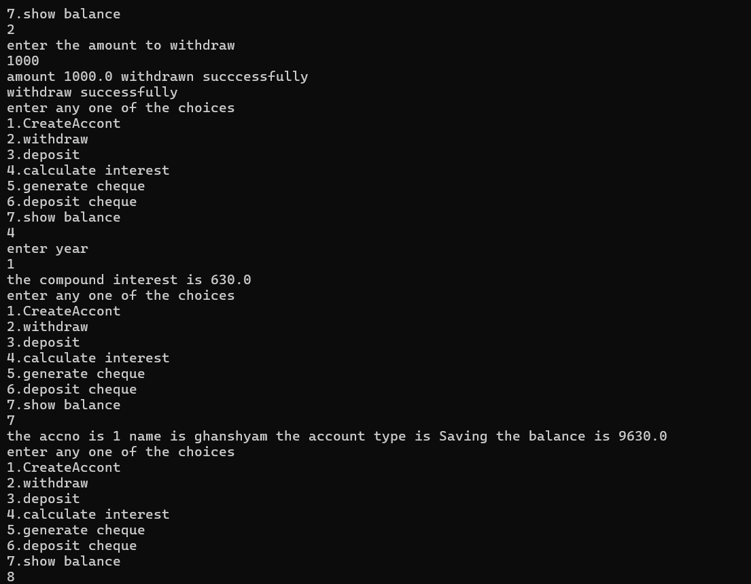

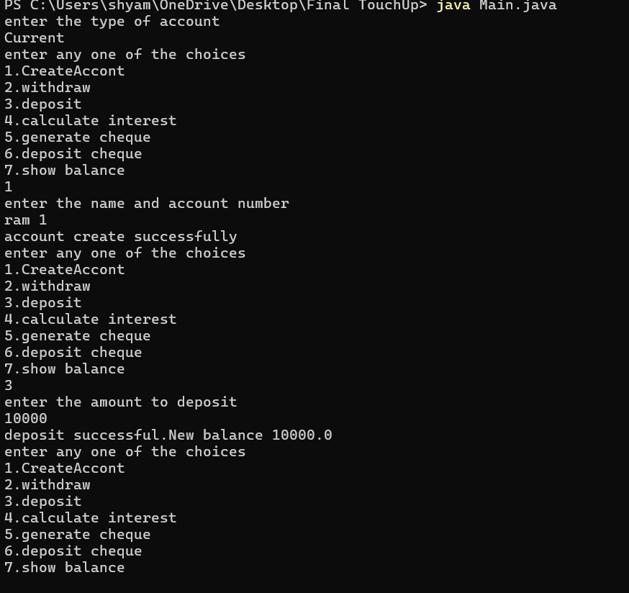

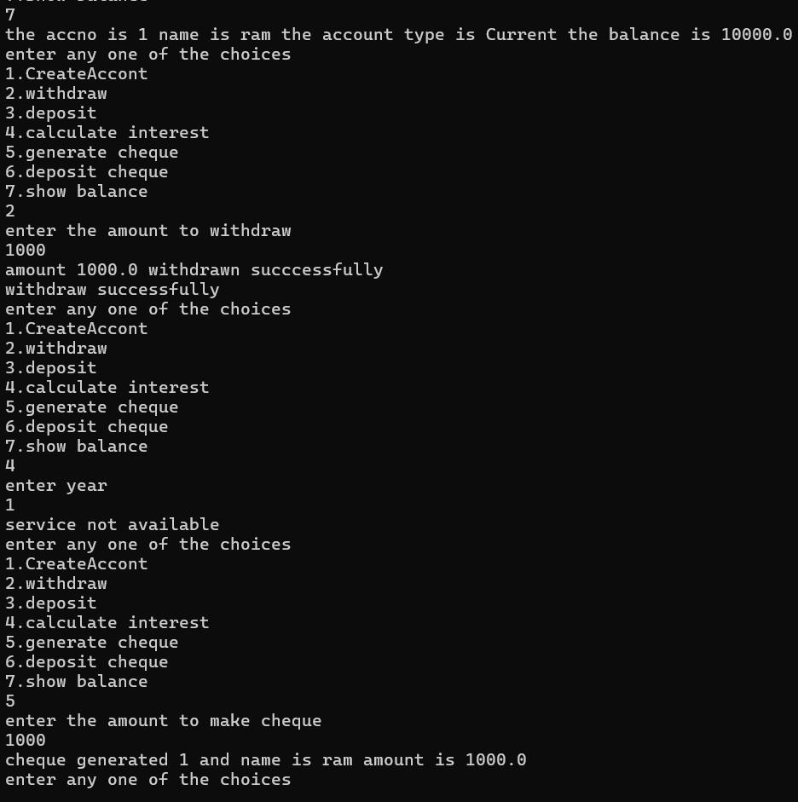

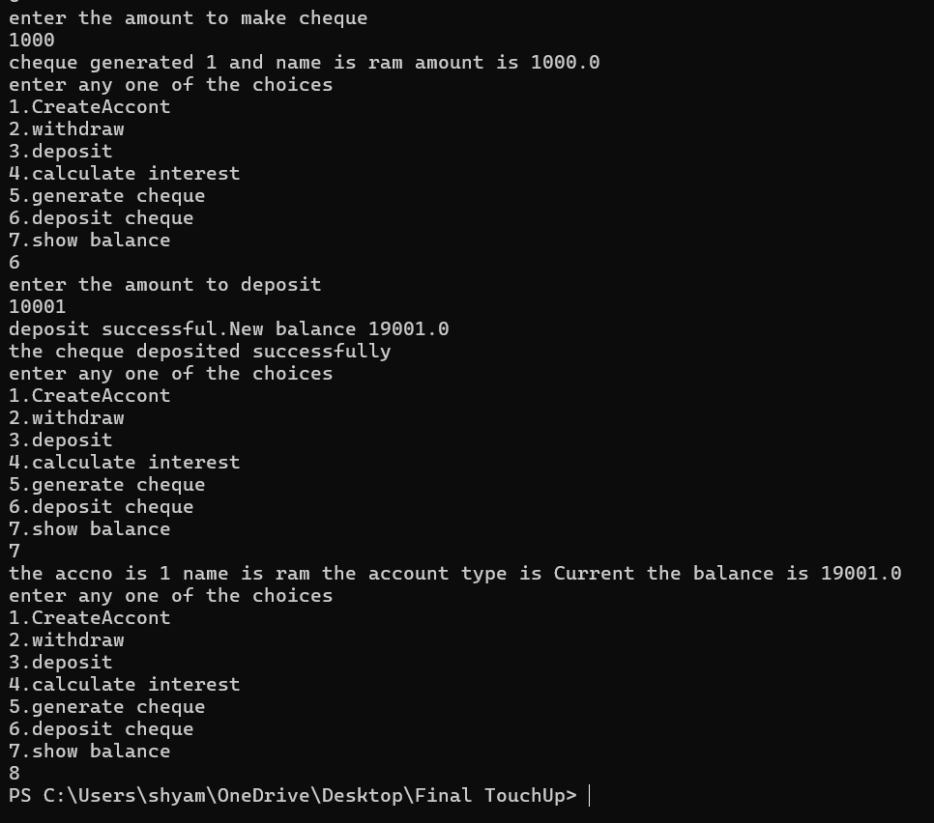

PROGRAM 6:

ALGORITHMS:

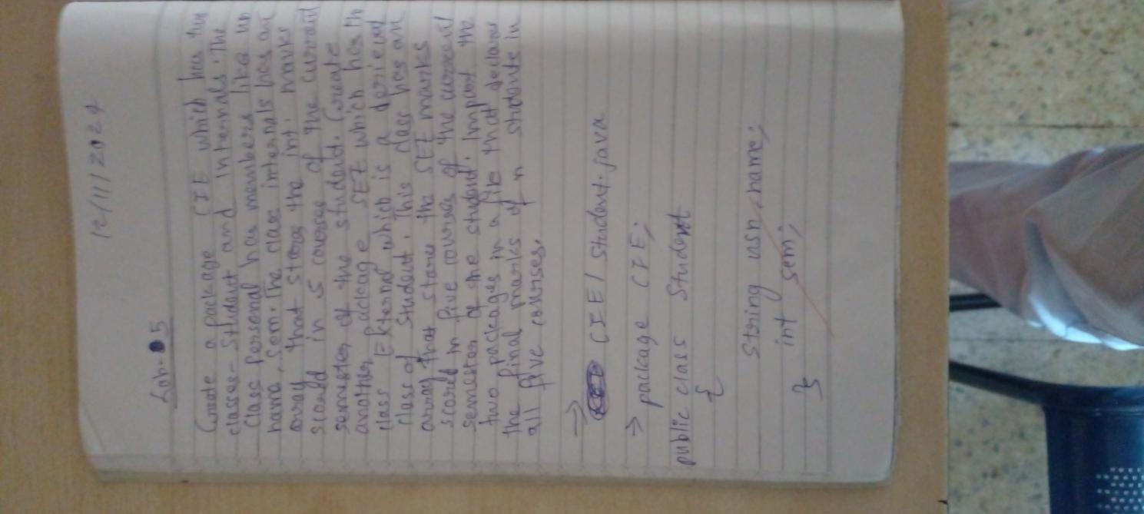

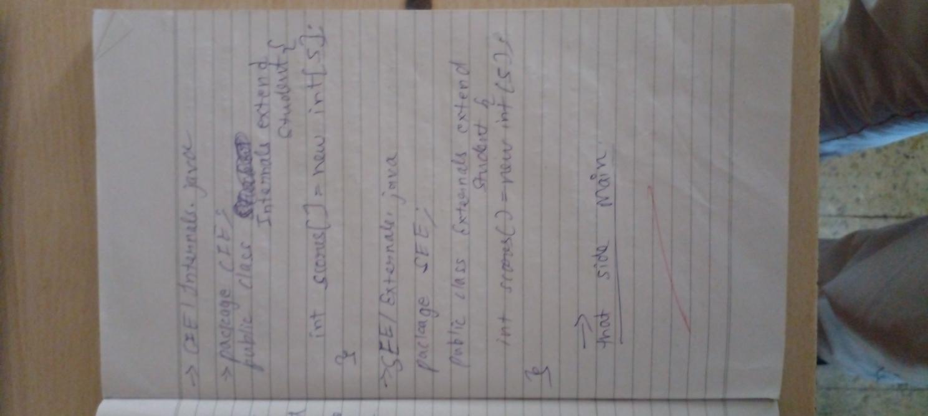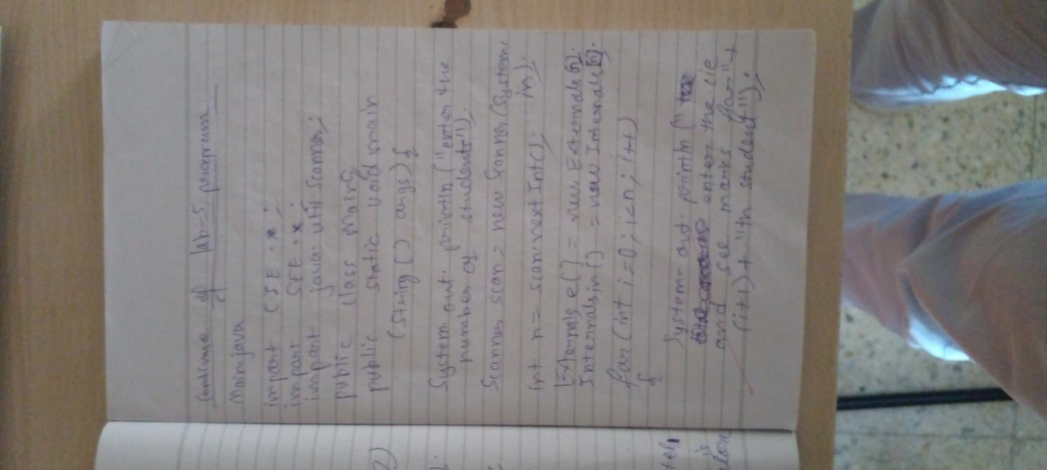

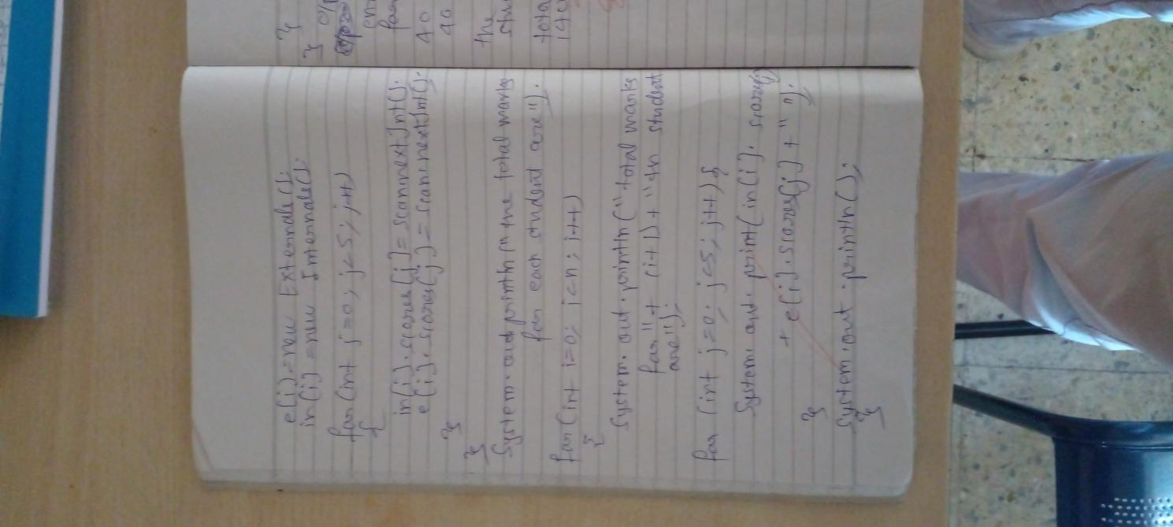

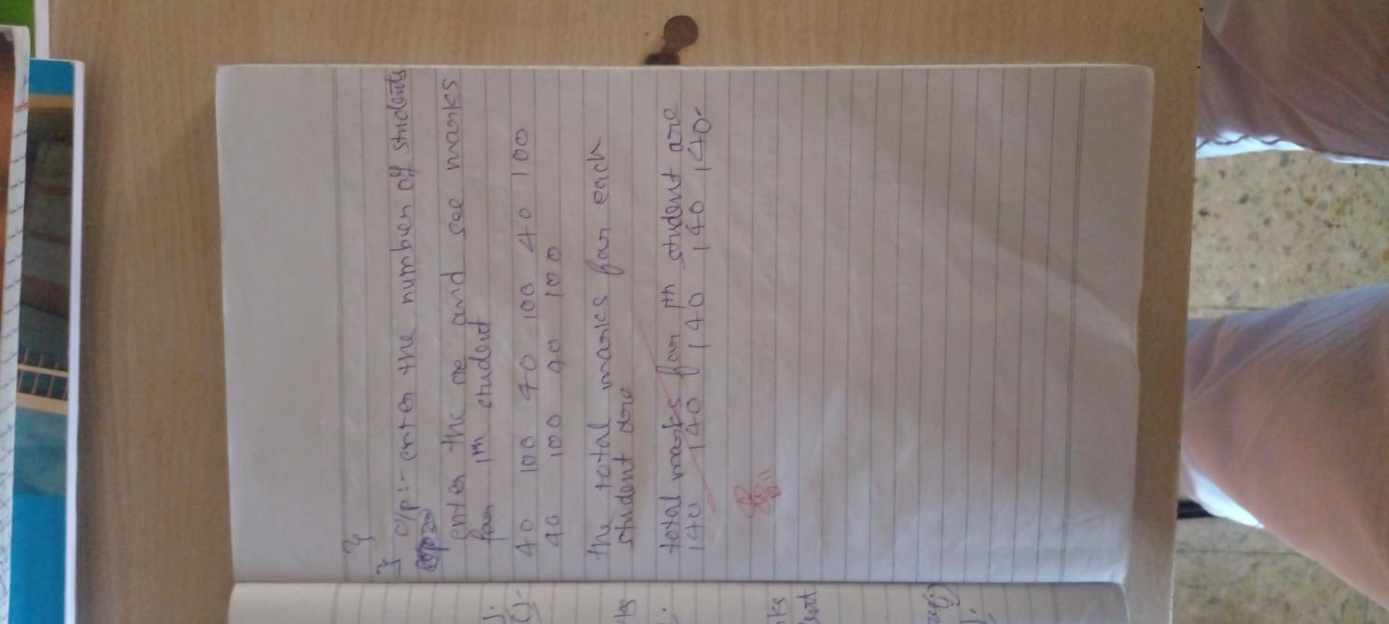CODE:

import CIE.*;

import SEE.*;

import java.util.Scanner;

public class Main{

public static void main(String args[]){

System.out.println("enter the number of students");

Scanner scan =new Scanner(System.in);

int n=scan.nextInt();

Externals ex[]=new Externals[n];

Internals in[]=new Internals[n];

for(int i=0;i<n;i++){

System.out.println("enter the name ,usn and sem along with their marks in cie and see");

String name=scan.next();

String usn=scan.next();

int sem=scan.nextInt();

in[i]=new Internals();

in[i].name=name;

in[i].usn=usn;

in[i].sem=sem;

ex[i]=new Externals();

ex[i].name=name;

ex[i].usn=usn;

ex[i].sem=sem;

for(int j=0;j<5;j++){

in[i].scores[j]=scan.nextInt();

ex[i].scores[j]=scan.nextInt();

}

}

System.out.println("the total marks for each student are");

for(int i=0;i<n;i++){

System.out.println("total marks for "+(i+1)+"th student are");

System.out.print("name : "+in[i].name+" usn :"+in[i].usn+" sem: "+in[i].sem);

for(int j=0;j<5;j++){

System.out.println(in[i].scores[j]+ex[i].scores[j]+" ");

}

System.out.println();

}

}

}

package SEE;

import CIE.Student;

public class Externals extends Student{

public int scores[]=new int[5];

}

package CIE;

public class Internals extends Student{

public int scores[]=new int[5];

}

package CIE;

public class Student{

public String usn,name;

public int sem;

}

OUTPUT:

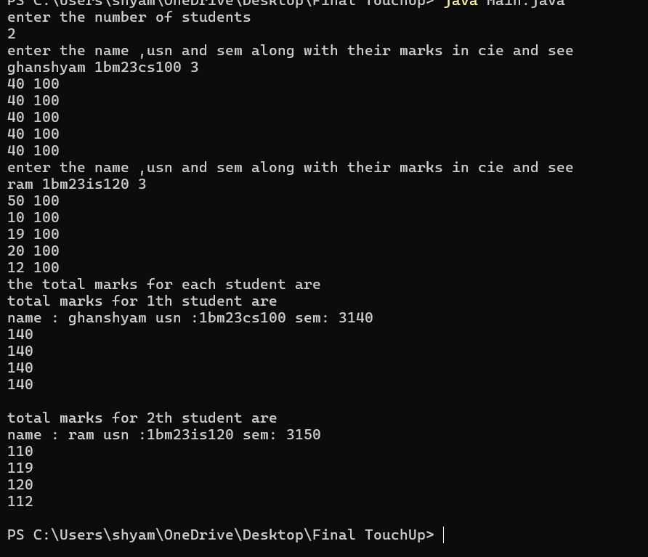

PROGRAM 7:

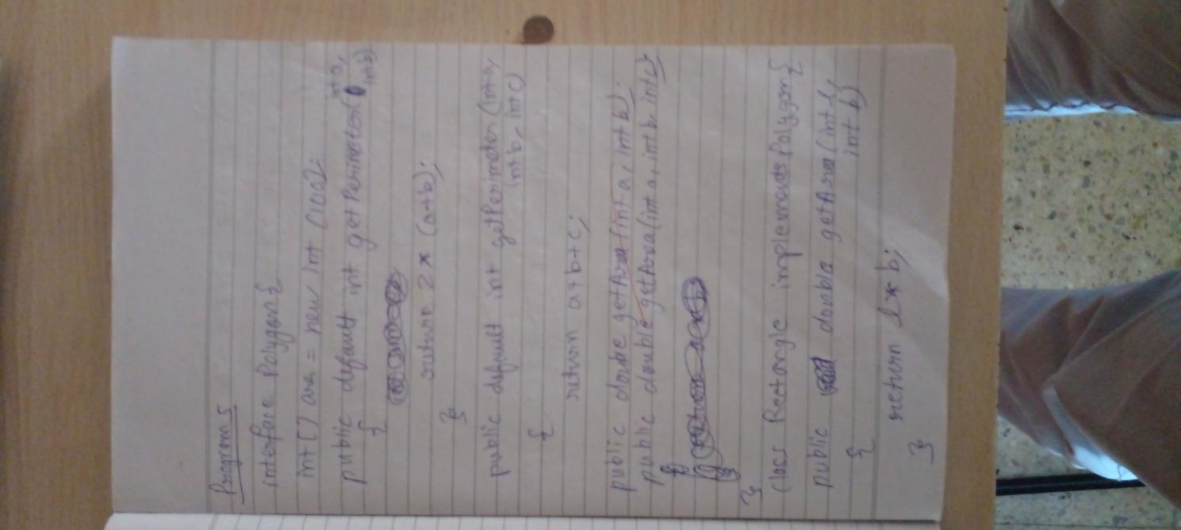

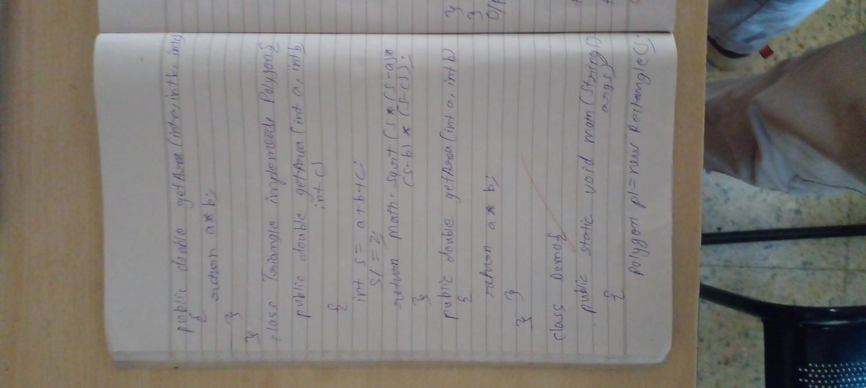

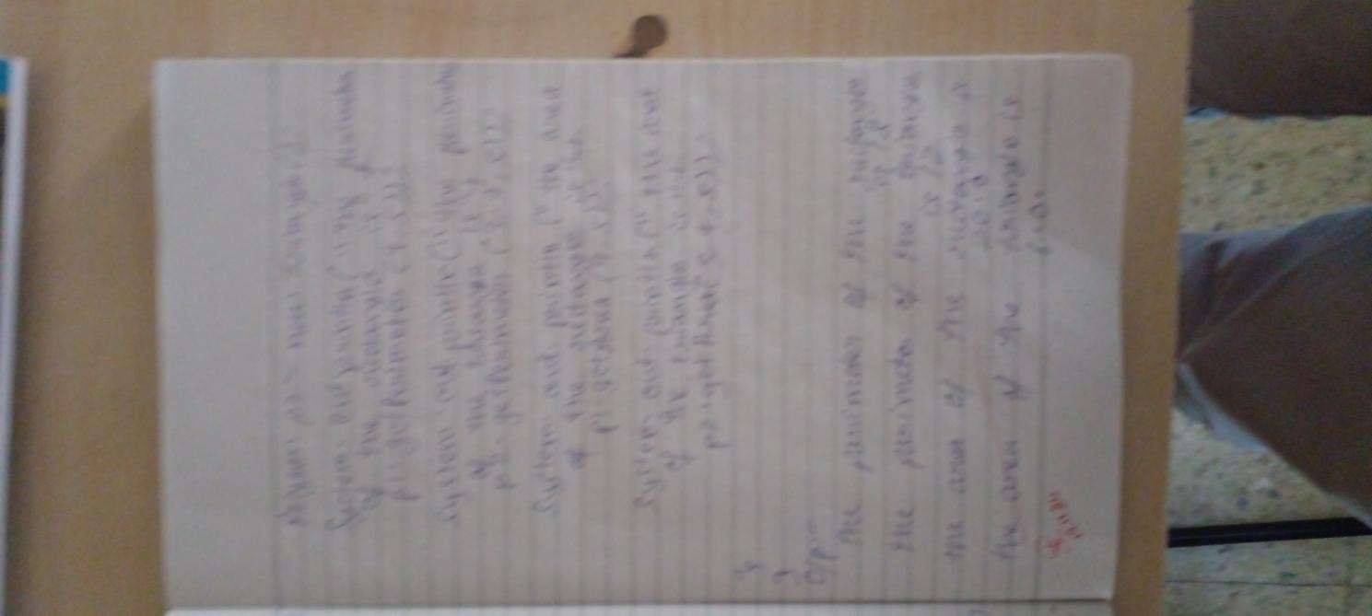ALGORITHMS:

CODE:

class Main{

public static void main(String[] args){

Rectangle p1=new Rectangle(4,5);

Triangle p2=new Triangle(3,4,5);

System.out.println("the perimeter of the rectangle is");

System.out.println(p1.getPerimeter());

System.out.println("the perimeter of the triangle is");

System.out.println(p2.getPerimeter());

System.out.println("the area of the rectangle is");

System.out.println(p1.getArea());

System.out.println("the area of the triangle is");

System.out.println(p2.getArea());

}

}

interface Polygon{

public default double getPerimeter(double a,double b){

return 2*(a+b);

}

public default double getPerimeter(double a,double b,double c){

return a+b+c;

}

public double getArea();

}

class Rectangle implements Polygon{

double a,b;

Rectangle(double a,double b){

this.a=a;

this.b=b;

}

public double getPerimeter(){

return Polygon.super.getPerimeter(a,b);

}

public double getArea(){

return a*b;

}

}

class Triangle implements Polygon{

double a,b,c;

Triangle(double a,double b,double c){

this.a=a;

this.b=b;

this.c=c;

}

public double getPerimeter(){

return Polygon.super.getPerimeter(a,b,c);

}

public double getArea(){

double s=(a+b+c)/2;

return Math.sqrt(s*(s-a)*(s-b)*(s-c));

}

}

OUTPUT:

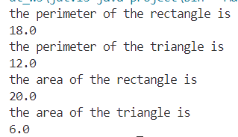

PROGRAM 8:

ALGORITHMS:

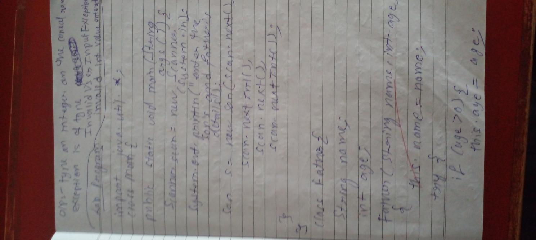

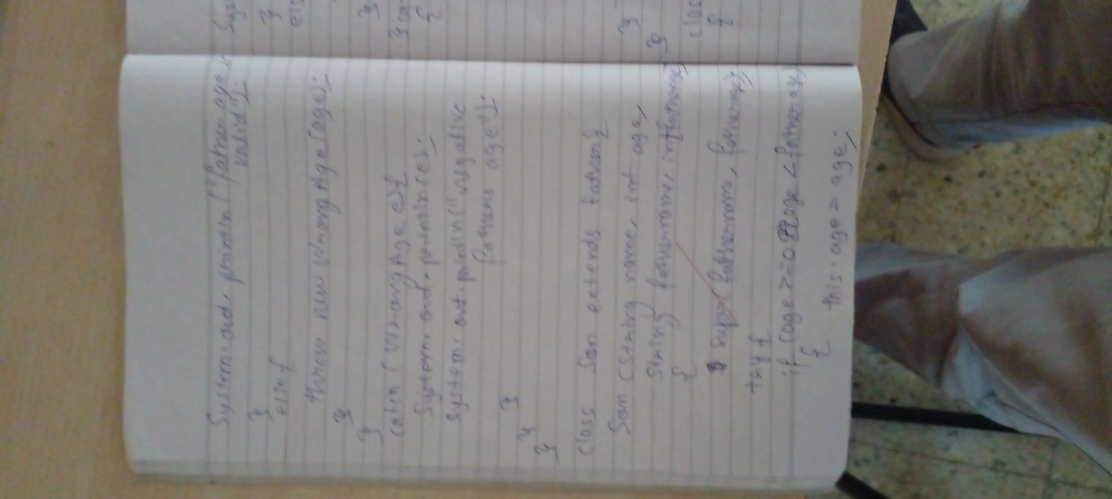

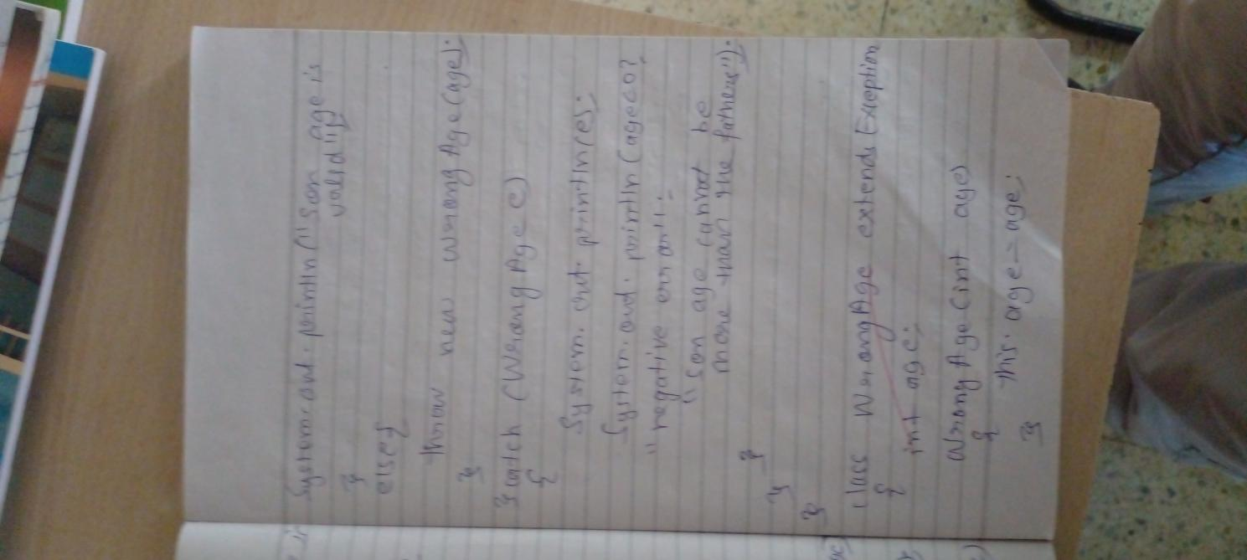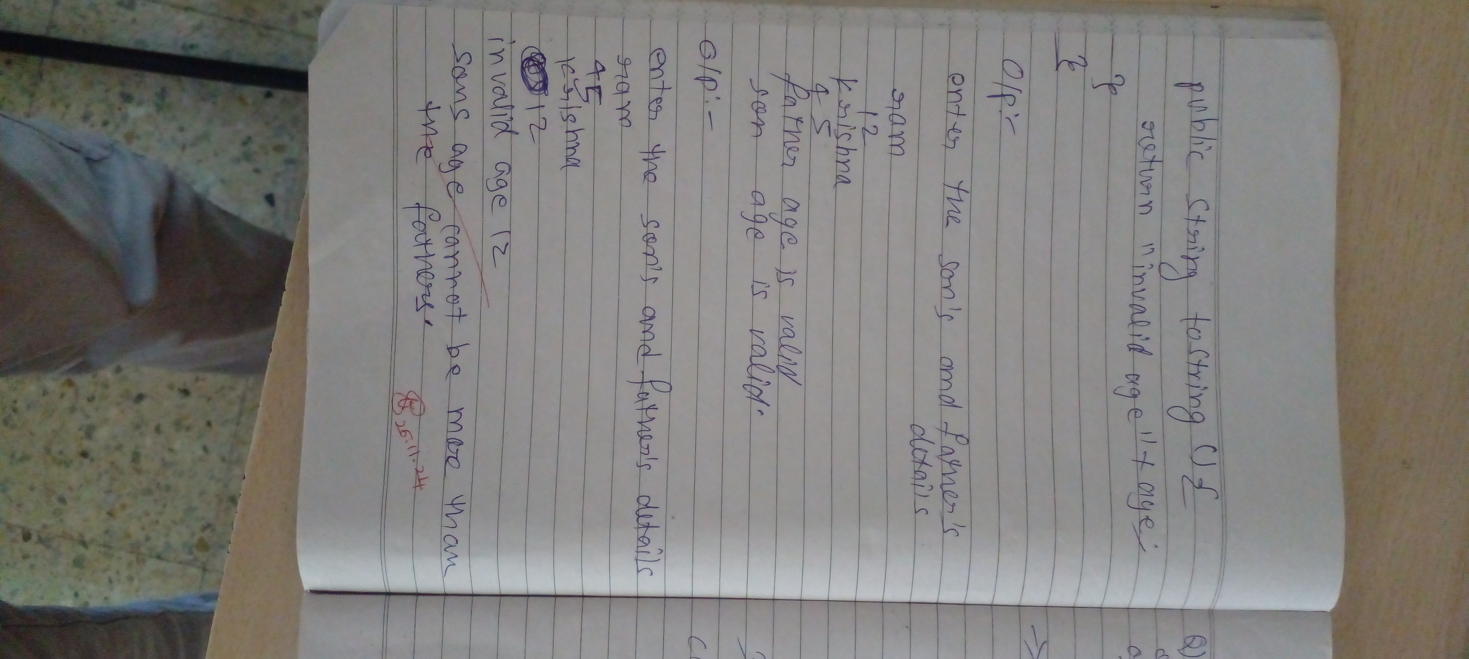CODE:

import java.util.*;

class Main{

public static void main(String[] args){

Scanner scan=new Scanner(System.in);

System.out.println("enter the son's and father's details");

Son s=new Son(scan.next(),scan.nextInt(),scan.next(),scan.nextInt());

}

}

class WrongAge extends Exception{

int age;

WrongAge(int age){

this.age=age;

}

public String toString(){

return "invalid age "+age;

}

}

class Father{

String name;

int age;

Father(String name,int age){

this.name=name;

try{

if(age>0){

this.age=age;

System.out.println("fathr age is valid");

}else{

throw new WrongAge(age);

}

}catch(WrongAge e){

System.out.println(e);

System.out.println("negative fathers age");

}

}

}

class Son extends Father{

Son(String name,int age,String FatherName,int fatherage){

super(FatherName,fatherage);

try{

if(age>=0 && age<fatherage){

this.age=age;

System.out.println("son age is valid");

}else{

throw new WrongAge(age);

}

}catch(WrongAge e){

System.out.println(e);

System.out.println(age<0?"negative error":"son age cannot be more than fathers");

}

}

}

OUTPUT: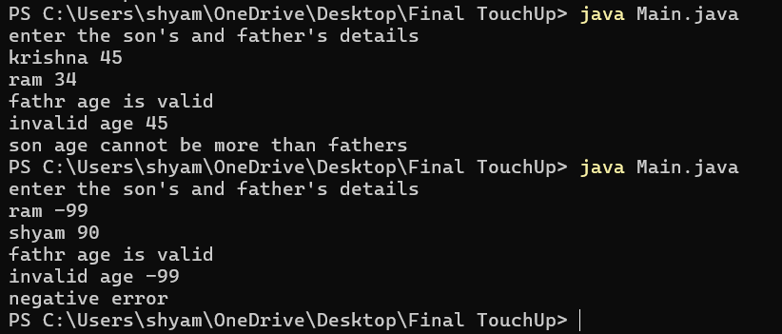

PROGRAM 9:

ALGORITHMS:

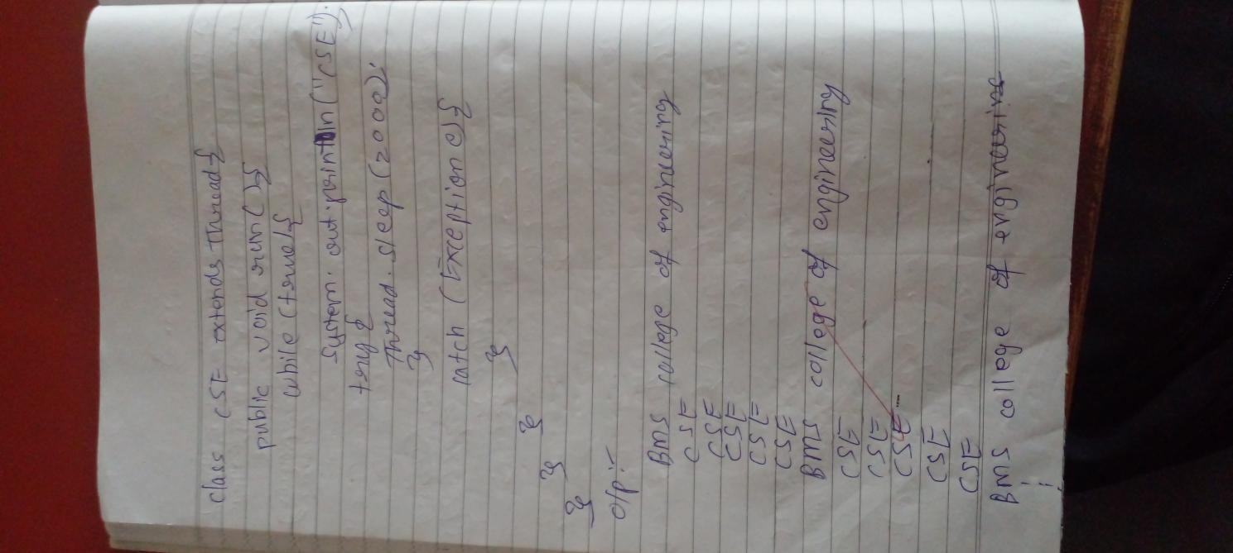CODE:class Main{

public static void main(String[] args){

BMS b=new BMS();

CSE c=new CSE();

b.start();

c.start();

}

}

class BMS extends Thread{

public void run(){

while(true){

System.out.println("BMS college of Engineering");

try{

Thread.sleep(10000);

}catch(Exception e){}

}

}

}

class CSE extends Thread{

public void run(){

while(true){

System.out.println("CSE");

try{

Thread.sleep(2000);

}catch(Exception e){}

}

}

}

OUTPUT: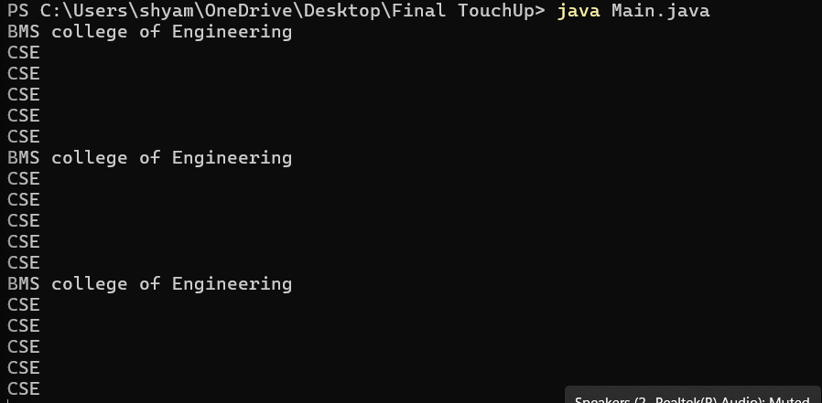

PROGRAM 10:

ALGORITHMS: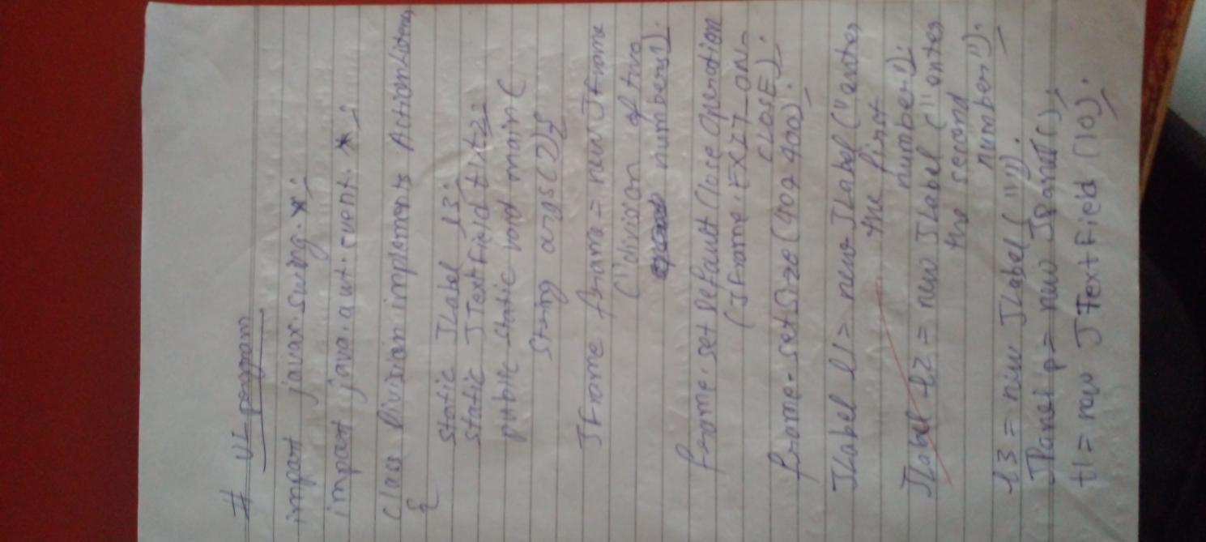

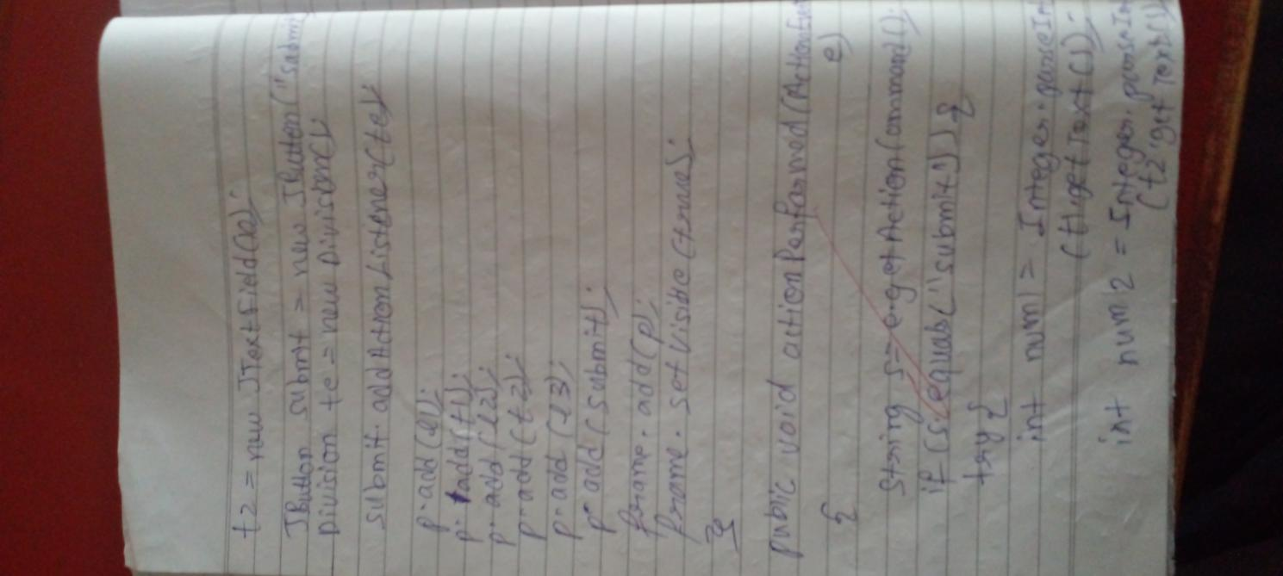

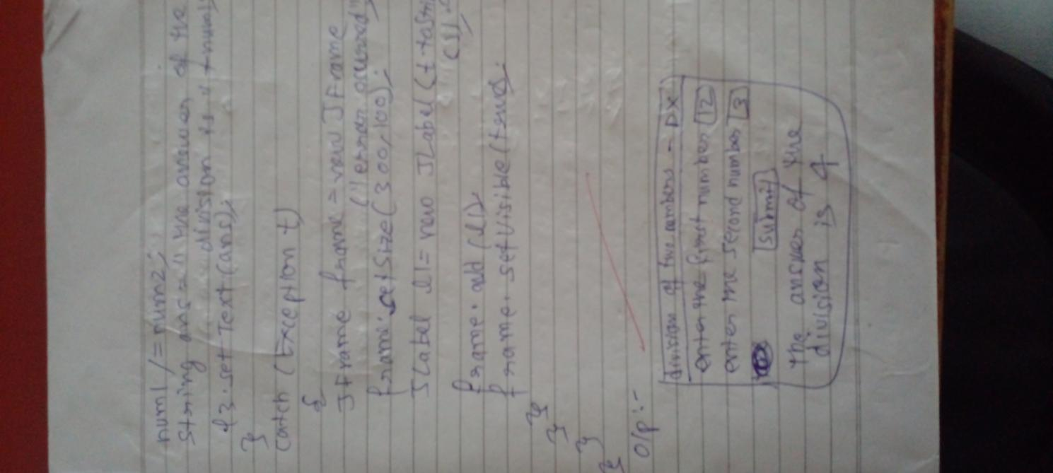

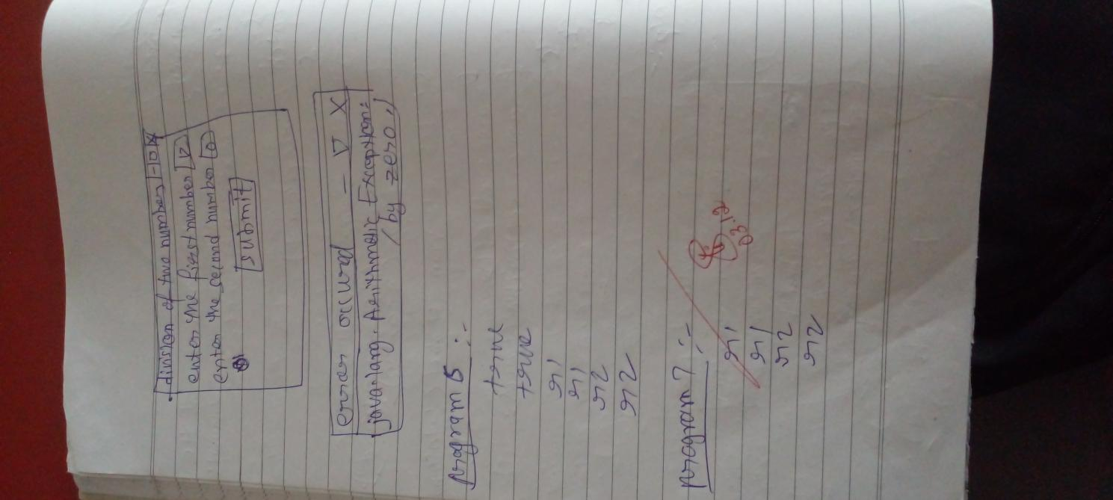

CODE:

import javax.swing.*;

import java.awt.event.*;

class Main implements ActionListener{

static JLabel l3;

static JTextField t1,t2;

public static void main(String[] args){

JFrame frame =new JFrame("division of two numbers");

frame.setDefaultCloseOperation(JFrame.EXIT_ON_CLOSE);

frame.setSize(400,400);

JLabel l1=new JLabel("enter the first number");

JLabel l2=new JLabel("enter the second number");

l3=new JLabel("");

JPanel p=new JPanel();

t1=new JTextField(10);

t2=new JTextField(10);

JButton submit=new JButton("submit");

Main te=new Main();

submit.addActionListener(te);

p.add(l1);

p.add(t1);

p.add(l2);

p.add(t2);

p.add(l3);

p.add(submit);

frame.add(p);

frame.setVisible(true);

}

public void actionPerformed(ActionEvent e){

String s=e.getActionCommand();

if(s.equals("submit")){

try{

int num1=Integer.parseInt(t1.getText());

int num2=Integer.parseInt(t2.getText());

num1/=num2;

String ans="the answer of the division is "+num1;

l3.setText(ans);

}catch(Exception t){

JFrame frame=new JFrame ("error occured");

frame.setSize(300,100);

JLabel l1=new JLabel(t.toString());

frame.add(l1);

frame.setVisible(true);

}

}

}

}

OUTPUT:

